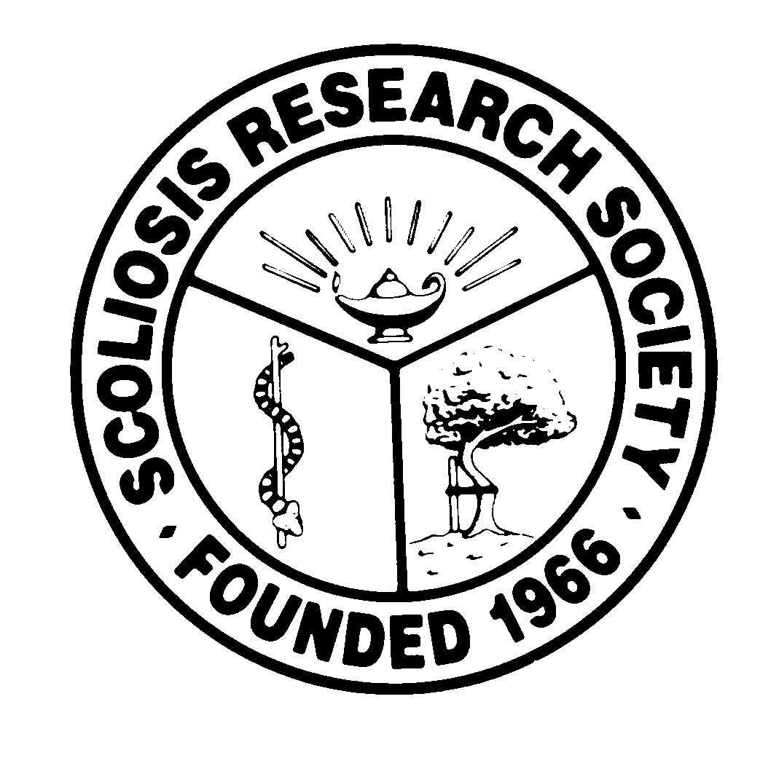
Scoliosis Research Society
Educational Activity Proposal
Please fax or email this form to Courtney Kissinger
at (414) 276-3349 or ckissinger@srs.org by January 11, 2016
Name: Amer Samdani

Email: amersamdani@gmail.com Phone: 215 287 5709

Type of Activity:

Annual Meeting
Pre-Meeting Course Half Day Course Lunchtime Symposium

Other (Please Specify):

Activity Title: Intraspinal Anomalies and Spine Deformity: Essentials and Current Concepts

Activity Chair: Amer F. Samdani, MD
Please list additional proposed faculty:
Steven W. Hwang, MD
Daniel J. Sucato, MD
Muharrem Yazici, MD
Please list proposed faculty:

Activity Description: This activity will focus on treatment of patients with both an intraspinal anomaly and spine deformity. The general outline is attached. We will begin with a general overview of the most common anomalies encountered, with emphasis on Chiari, different types of syrinx, and tethered cord. Then we will discuss in detail the most common patient presentation encountered, i.e. Chiari malformation/syrinx. This will be followed by a discussion of split cord malformations, which are relatively rare but important to understand. Lastly, we will discuss the role of vertebral column shortening in patients with difficult-to-treat intraspinal anomalies and severe deformity. We will finish with a panel discussion of two case illustrations.

What do you hope to accomplish by offering this activity? What problems in patient care or other work related to the practice of medicine do you hope to address?
- Enhance surgeons’ understanding of the variety of deformities seen and management strategies for the most common ones.
- Present newer concepts for treatment of patients with intraspinal anomalies and spine deformity; in particular, the role of vertebral column shortening and times when an anomaly can be left alone.

After this activity has been completed, what steps will be taken to reinforce the education presented? How will an improvement in clinical practice be assessed?
We will do case presentations at the end of the activity to reinforce important concepts. We will provide a detailed handout emphasizing key concepts and conduct a post activity survey to better understand the impact on clinical practice.

