**Can MRSA Biofilm Infections Be Cleared from Pedicle Screws Intraoperatively?**

Daniel G. Meeker BS1, Karen E. Beenken PhD1, Weston B. Mills BA1, Richard E. McCarthy MD2, Mark S. Smeltzer PhD1, David B. Bumpass MD2

1 Department of Microbiology & Immunology, University of Arkansas for Medical Sciences, Little Rock, Arkansas, USA.

2 Department of Orthopaedics, University of Arkansas for Medical Sciences, Little Rock, Arkansas, USA.

Daniel G. Meeker: University of Arkansas for Medical Sciences; Mail Slot 511; 4301 W Markham; Little Rock, AR 72205; Telephone: (501) 686-5254; Fax: (501) 686-6742; dmeeker@uams.edu

**Abstract**

**Summary.** Pedicle screws contaminated with a virulent strain of biofilm-forming community-acquired methicillin-resistant *Staphylococcus aureus* (CA-MRSA) and a strain of biofilm-forming methicillin-sensitive *S. aureus* (MSSA) can be effectively and easily decontaminated intraoperatively. Avoiding the need to exchange spine implants in deep wound infections (DWI) could result in significant cost savings for these revision procedures.

**Hypothesis.** In an *in vitro* model of DWI, multiaxial pedicle screws can be effectively decontaminated using common surgical disinfectant solutions conducive to intraoperative use.

**Design.** *In vitro* microbiologic study.

**Introduction.** DWIs after spinal instrumentation are morbid and extremely costly, often requiring implant exchange. Incidence of CA-MRSA surgical infections is increasing; these bacteria form biofilms, further enhancing their antibiotic resistance. Identifying strategies for reducing costs in treating DWIs is crucial as cost-control pressures increase on hospitals and providers.

**Methods.** Multiaxial titanium (T) and stainless steel (SS) pedicle screws were coated in human plasma and colonized with the CA-MRSA strain LAC or the MSSA strain UAMS-1 grown in biofilm media. Screws were treated by soaking in various solutions for 15 or 30 min. T and SS screws that had been colonized with both strains of *S. aureus* were also treated with phosphate-buffered saline (PBS) as a negative control. T and SS screws were colonized with biofilms from both strains were treated with 10% povidone-iodine (PI) solution. Additionally, 6 T and 6 SS screws were colonized with the MRSA strain LAC and were treated with 3% hydrogen peroxide solution. After treatment in the disinfectant solution, screws were sonicated to remove non-adherent bacteria, and viable colony forming units (cfu) were determined by serial dilutions. Screw sterility was also confirmed by incubating screws in tryptic soy broth following treatment and sonication.

**Results.** Overall, 30-min PI treatment resulted in a 99% *S. aureus* decontamination rate, while 15-min PI treatment resulted in a 79% decontamination rate. Hydrogen peroxide was ineffective at decontaminating any screw, with all screws retaining 102-104 cfu following treatment. As anticipated, all control PBS-treated screws remained fully colonized post-treatment. Combining data from 30-min and 15-min treatment groups, PI resulted in an overall 97% decontamination rate for screws colonized with an MSSA biofilm and an 87% decontamination rate for screws colonized with an MRSA biofilm.

**Conclusion.** Treating contaminated pedicle screws with a 30-min PI soak resulted in a 99% bacterial elimination rate, even despite complex multiaxial screw geometry in the presence of intrinsically resistant biofilm-forming MRSA and MSSA strains. These results suggest that pedicle screws could potentially be removed intraoperatively, sterilized on the surgical field in PI, and re-implanted with minimal risk of continued infection, significantly reducing the cost for revision spine surgery after infection.

**Introduction**

Deep wound infection (DWI) remains one of the most challenging and expensive complications after instrumented spinal fusion. Recent reported rates hover around 2%, with higher rates for deformity (4%) and spinal trauma cases (9%) [1]. The cost of treating DWI after lumbar fusion has been reported to exceed $30,000 per case [2]. Spinal implant removal is often necessary to clear DWI, particularly in the case of delayed infection [3]. Implant exchange can dramatically escalate the cost of treating spinal DWI, particularly in deformity cases with long constructs. In the current cost-containment environment, identifying strategies to reduce the cost of treating spinal infections is increasingly necessary.

*Staphylococcus aureus* is one of the most predominant pathogens causing post-surgical DWI and infections of indwelling medical devices [4]. *S. aureus* accounts for 49-58% of spinal DWI cases, with 38-57% of these being methicillin-resistant *S. aureus* (MRSA) [5-6]*.* The propensity for *S. aureus* to cause implant-associated infections is owed, at least in part, to its ability to form a biofilm [7]. A biofilm consists of bacterial cells bound to each other and/or a surface within a protective extracellular matrix (**Fig. 1**). Formation of a biofilm promotes the persistence of pathogens in the context of chronic infection and more importantly, confers a degree of intrinsic resistance on the bacteria residing within the biofilm [8]. This intrinsic resistance refers to a tolerance of biofilm-associated bacteria to any conventional antimicrobial therapy, and results in inadequate responses to conventional antimicrobial therapy [9]. Surgical intervention to remove infected implants and tissue then becomes necessary [10].

The purpose of our study was to investigate whether multiaxial pedicle screws can be reliably decontaminated in an intraoperative setting using commonly available sterilization solutions, using an *in vitro* model of *S. aureus* infection. We hypothesized that the screws could be sterilized despite biofilm formation and complex screw geometry, given adequate time of exposure to sterilization.

**Materials and Methods**

**Bacterial strains used.** The strains included in this study were the USA300 community-acquired methicillin-resistant *S. aureus* (CA-MRSA) strain LAC and the USA200 methicillin-sensitive *S. aureus* (MSSA) strain UAMS-1. These strains were chosen because they are diverse both in terms of phenotype and genotype, both are clinical isolates, and both are representative of common clinically relevant clonal lineages.

**Antimicrobial assessment.** Experiments were performed using a model for *in vitro* biofilm formation (Weiss et al. 2009) with some modifications. Multiaxial stainless steel (SS) pedicle screws and multiaxial titanium (T) screws (Medtronic Sofamor Danek, Memphis, TN) were sterilized and coated in human plasma at 4°C for 16 hrs before being placed in individual sterile conical tubes containing enough tryptic soy broth (TSB) supplemented with glucose and sodium chloride (biofilm media [BFM]) to completely cover each screw (**Fig. 2**). Each tube was then inoculated with LAC or UAMS-1 at an optical density at 560 nm (OD560) of 0.05. Screws were incubated at 37°C for 24 hrs to allow for the formation of biofilms on the surface of the screws. Screws were then rinsed in sterile phosphate buffered saline (PBS) to remove non-adherent bacteria and placed into individual sterile pipette reservoirs containing PVP Prep Solution (povidone-iodine 10%, Medline, Northfield, IL) such that the povidone-iodine solution (PI) completely covered the screws. Screws were exposed to PI for either 15 or 30 minutes. Untreated screws were exposed to sterile PBS for the same durations to serve as controls. Additionally, groups of SS and T screws colonized with LAC were exposed to hydrogen peroxide, USP 3% (Medline, Northfield, IL), for 30 minutes as a separate experimental treatment.

Following treatment, all screws were rinsed in sterile PBS to remove excess sterilization solution and non-adherent bacteria, and were placed into sterile conical tubes containing enough sterile PBS to completely cover the screws. The screws were then sonicated using a sonicating probe (QSonica S4000, Newtown, CT) as previously described [8]. This procedure has been demonstrated to remove adherent biofilm-associated *S. aureus* cells without impacting bacterial viability. Viable colony-forming units (cfu) were then determined by serial dilution and drop plating on tryptic soy agar. Finally, screws were transferred to sterile conical tubes containing sterile TSB and incubated at 37°C for 24 hrs to assess for growth and confirm sterility of treated screws. This was confirmed by lack of visual turbid growth after 24 hrs.

**Scanning electron microscopy.** Biofilm formation was assessed microscopically using 0.6 mm stainless steel Kirschner wires (K-wire). K-wires were first cut into 1.0 cm segments and then coated with human plasma at 4°C for 16 hrs before being placed into the wells of a 12-well microtiter plate containing 2 ml of BFM. Each well was then inoculated with LAC at an OD560 of 0.05. The plate was then incubated at 37°C for 24 hrs before the pins were removed, rinsed in PBS to remove nonadherent bacteria, and then placed in 3% glutaraldehyde for 16 hrs at 4°C for fixation. Biofilms were post-fixed in 1% osmium tetroxide for 4 hrs and dehydrated by increasing ethanol series (30-100%). The samples were processed in a Leica CPD300 critical point dryer (Leica Microsystems, Buffalo Grove, IL) and were subsequently mounted on metal bases and sputter coated with gold using the Denton Desk V (Denton Vacuum, Moorestown, NJ). The samples were then examined with a JEOL JCM-6000 benchtop scanning electron microscope (JEOL USA, Peabody, MA).

**Results**

As anticipated, all control PBS-treated screws treated remained colonized in both strains following 30-minute exposure (**Fig. 3-6**). SS screws remained colonized with 8 × 107 cfu per screw (n = 22) while T screws remained colonized with approximately 7 × 108 cfu per screw (n = 22). All SS and T screws colonized with the MRSA strain LAC remained colonized following 30-minute exposure to 3% hydrogen peroxide (n = 12, data not shown). Screws colonized with the MSSA strain UAMS-1 were not exposed to 3% hydrogen peroxide, given the poor clearance results seen with LAC.

Conversely, treatment of pedicle screws with a 30-minute PI exposure cleared infection with a 99% success rate, combining data from the MSSA and MRSA groups and including both metal types (n = 84). Exposure to PI of SS and T screws colonized with the MSSA strain UAMS-1 resulted in clearance of viable bacteria from 100% of screws exposed for 30 minutes (n = 40) and 91.7% of screws exposed for 15 minutes (n = 24; **Fig. 3-4**). SS screws that remained colonized following 15-minute PI exposure were colonized with 7 × 103 cfu per screw while T screws remained colonized with 8 × 102 cfu per screw. For screws colonized with the MRSA strain LAC, exposure to PI for 30 minutes resulted in clearance of viable bacteria from 100% of SS screws (n = 22) and 95.5% of T screws (n = 22; **Fig. 5-6**). After reducing treatment time with PI to 15 minutes, 100% of SS screws (n = 12) were still cleared, but only 33.3% of T screws (n = 12) were cleared (**Fig. 5-6**). T screws that remained contaminated with LAC after 30-minute PI exposure were colonized with 8 × 102 cfu per screw while those that remained colonized after 15-minute PI exposure were colonized with 7 × 106 cfu per screw, a much larger bacterial load. When comparing results between the MRSA strain LAC and the MSSA strain UAMS-1 using both metal types, a lower clearance rate was observed with LAC than with UAMS-1 (86.8% vs. 96.9%).

**Discussion**

The data generated in this report suggest that a 10% povidone-iodine solution can reliably sterilize multiaxial pedicle screws inoculated with biofilm-forming MSSA and MRSA,with a minimum exposure time of 30 minutes. To the authors’ knowledge, this proof-of-concept *in vitro* study is the first to demonstrate that multiaxial pedicle screws can be cleared of these infections with high reproducibility using common, inexpensive sterilization solutions found in most operating rooms. The complex geometry of these screws provide numerous surfaces for biofilm formation that may not be accessible to *in situ* macroscopic debridement in an infected patient.

Overall, our data demonstrate that both tested strains of *S. aureus* can effectively colonize and form robust biofilms on the surface of both SS and T multiaxial pedicle screws. Furthermore, control PBS-treated groups demonstrate that these biofilms are not disrupted by simple rinsing with a buffer solution. Generally, T screws tend to be colonized with approximately one log greater cfu per screw than did SS screws, suggesting that T may be more susceptible to colonization than SS in this *in vitro* model. This is also reflected in the overall clearance rates following PI exposure for the two metal types independent of colonizing strain (98.5% clearance of SS screws vs. 85.3% clearance of T screws). However, this is likely to be impacted by size, shape, roughness of metal surface, and other factors. Exposure of both SS and T screws to 3% hydrogen peroxide was completely unsuccessful at eliminating viable bacteria, suggesting that 3% hydrogen peroxide is not a viable option for a surgical disinfectant solution to be used to decontaminate multiaxial pedicle screws intraoperatively.

Additionally, although both strains of *S. aureus* have been shown to form robust, intrinsically-resistant biofilms, it has been previously demonstrated that UAMS-1 forms a more robust biofilm than does LAC [9]. However, despite this difference, a higher rate of clearance was observed in pedicle screws colonized with the MSSA strain UAMS-1 than with the MRSA strain LAC, as noted above. One possible explanation for this is a relative tolerance of LAC for povidone-iodine solutions. It is unclear at this time whether this trend correlates with or is dependent upon methicillin resistance status or if this finding expands to other possible disinfectant solutions. Further studies are required to elucidate interaction between antibiotic resistance status and tolerance to common disinfectant solutions.

There are several limitations to our study. First, this is an *in vitro* model, and does not incorporate or account for the role of soft tissues on infection persistence after debridement. Similarly, our model did not incorporate gross tissue debris on the screws. Second, while *S. aureus* is a predominant pathogen responsible for causing implant-associated orthopaedic infections, it should be noted that *S. aureus* is not the sole causative pathogen. More work is needed to determine the effectiveness of PI and other disinfectant solutions in decontaminating implants colonized with alternative pathogens, particularly Gram negative infections which often affect neuromuscular fusion patients.

In this study we do not seek to state if or when pedicle screws should be removed and reinserted in infected patients. There are potential biomechanical implications of doing so, in addition to infection-related implications. In an *in vivo* setting, screws that are loose secondary to osteomyelitis in the pedicle would likely need to be removed and upsized. However, Lehman et al. did demonstrate that removal and reinsertion of a pedicle screw into otherwise stable bone did not reduce screw pullout strength [11].

It is likely that the addition of physical disruption of a biofilm by scrubbing during exposure to a surgical disinfectant would further enhance and/or accelerate the decontamination of contaminated implants. Our current model did not incorporate this variable, but we plan further studies to investigate how we might shorten the decontamination time to better facilitate possible intraoperative use of this technique.

**Conclusions**

In summary, we have demonstrated proof of concept for the possibility that pedicle screws can be reliably sterilized of biofilm-forming MRSA and MSSA strains in an intraoperative setting using povidone-iodine solution. We plan further investigation to demonstrate that this technique can allow pedicle screws to be safely cleaned and re-used in DWI after spinal fusion, potentially leading to substantial cost savings in treating these severe infections.

**References**

1. Boody BS, Jenkins TJ, Hashmi SZ, Hsu WK, Patel AA, Savage JW: Surgical Site Infections in Spinal Surgery. *J Spinal Disord Tech* 2015;28(10): 352-362.
2. Culler SD, Jevsevar DS, Shea KG, McGuire KJ, Schlosser M, Wright KK, Simon AW: Incremental Hospital Cost and Length-of-Stay Associated With Treating Adverse Events Among Medicare Beneficiaries Undergoing Lumbar Spinal Fusion During Fiscal Year 2013. *Spine* 2016; 41(20):1613-1620.
3. Lall RR, Wong AP, Lall RR, Lawton CD, Smith ZA, Dahdaleh NS: Evidence-based management of deep wound infection after spinal instrumentation. *J Clin Neurosci* 2015; 22(2):238-42.
4. Korol E, Johnston K, Waser N, Sifakis F, Jafri HS, Lo M, Kyaw MH: A systematic review of risk factors associated with surgical site infections among surgical patients. *PLoS One* 2013; 8(12):e83743.
5. Patel PK, Mantey J, Mody L: Patient Hand Colonization With MDROs Is Associated with Environmental Contamination in Post-Acute Care. *Infect Control Hosp Epidemiol* 2017; doi: 10.1017/ice.2017.133.
6. Chen SH, Lee CH, Huang KC, Hsieh PH, Tsai SY: Postoperative wound infection after posterior spinal instrumentation: analysis of long-term treatment outcomes. *Eur Spine J* 2015; 24(3):561-70.
7. Brady RA, Leid JG, Calhoun JH, Costerton JW, Shirtliff ME: Osteomyelitis and the role of biofilms in chronic infection. *FEMS Immunol Med Microbiol* 2008;52(1):13-22.
8. Weiss EC, Spencer HJ, Daily SJ, Weiss BD, Smeltzer MS: Impact of *sarA* on antibiotic susceptibility of *Staphylococcus aureus* in a catheter-associated in vitro model of biofilm formation. *Antimicrob Agents Chemother* 2009;53(6):2475-82.
9. Meeker DG, Beenken KE, Mills WB, Loughran AJ, Spencer HJ, Lynn WB, Smeltzer MS: Evaluation of Antibiotics Active against Methicillin-Resistant *Staphylococcus aureus* Based on Activity in an Established Biofilm. *Antimicrob Agents Chemother* 2016;60(10):5688-94.
10. Darouiche RO: Treatment of infections associated with surgical implants. *N Engl J Med* 2004;350(14):1422-9.
11. Kang DG, Lehman RA Jr, Wagner SC, Bevevino AJ, Bernstock JD, Gaume RE, Dmitriev AE: Pedicle screw reinsertion using previous pilot hole and trajectory does not reduce fixation strength. *Spine* 2014;39(20):1640-7.

**Figure Legends**

**Figure 1.** Scanning electron microscope (SEM) images of LAC biofilms grown on K-wire at a magnification of (A) 1000×, (B) 4500×, (C) 8500×, and (D) 17,000×.

**Figure 2.** Image of titanium (left) and stainless steel (right) multiaxial pedicle screws.

**Figure 3.** Stainless steel screws colonized with UAMS-1 and treated with PI for 0, 15, or 30 minutes. Colonization is represented as percentage of screws completely cleared of viable bacteria.

**Figure 4.** Titanium screws colonized with UAMS-1 and treated with PI for 0, 15, or 30 minutes. Colonization is represented as percentage of screws completely cleared of viable bacteria.

**Figure 5.** Stainless steel screws colonized with LAC and treated with PI for 0, 15, or 30 minutes. Colonization is represented as percentage of screws completely cleared of viable bacteria.

**Figure 6.** Titanium screws colonized with LAC and treated with PI for 0, 15, or 30 minutes. Colonization is represented as percentage of screws completely cleared of viable bacteria.

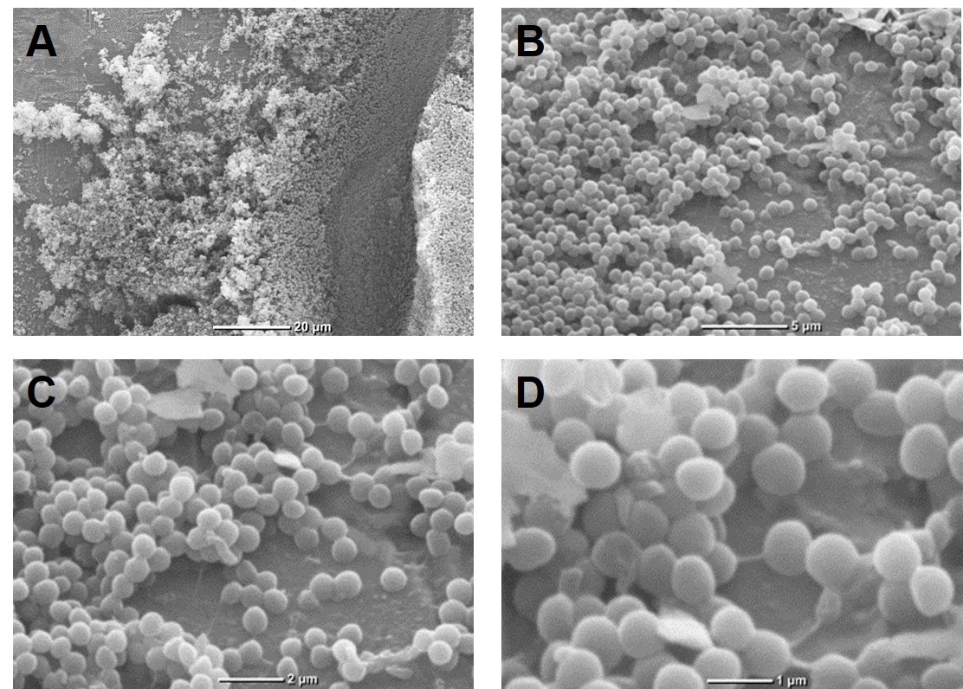

Figure 1

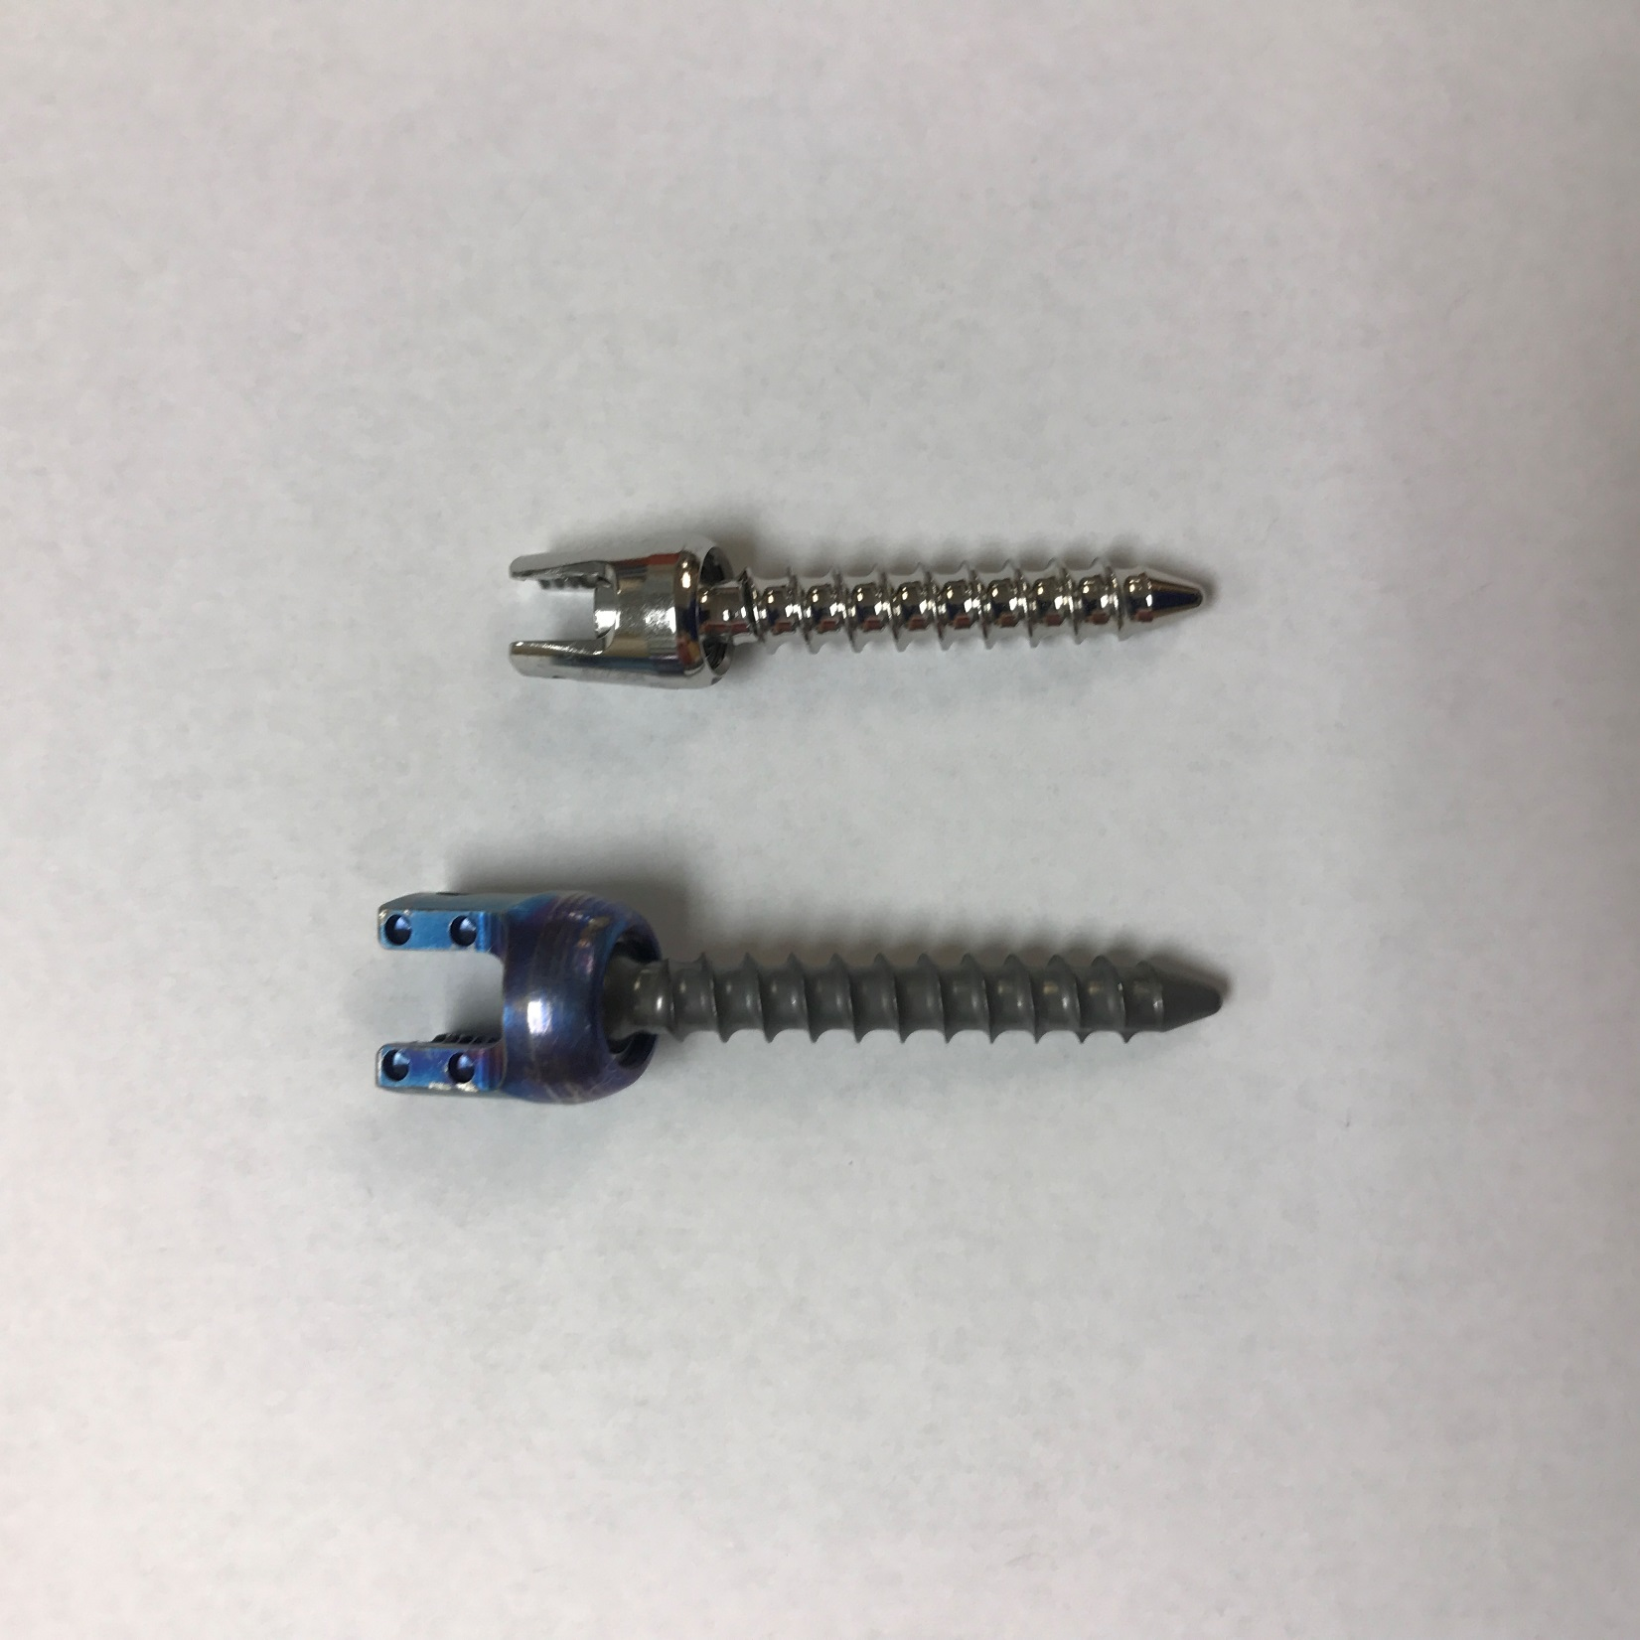

Figure 2

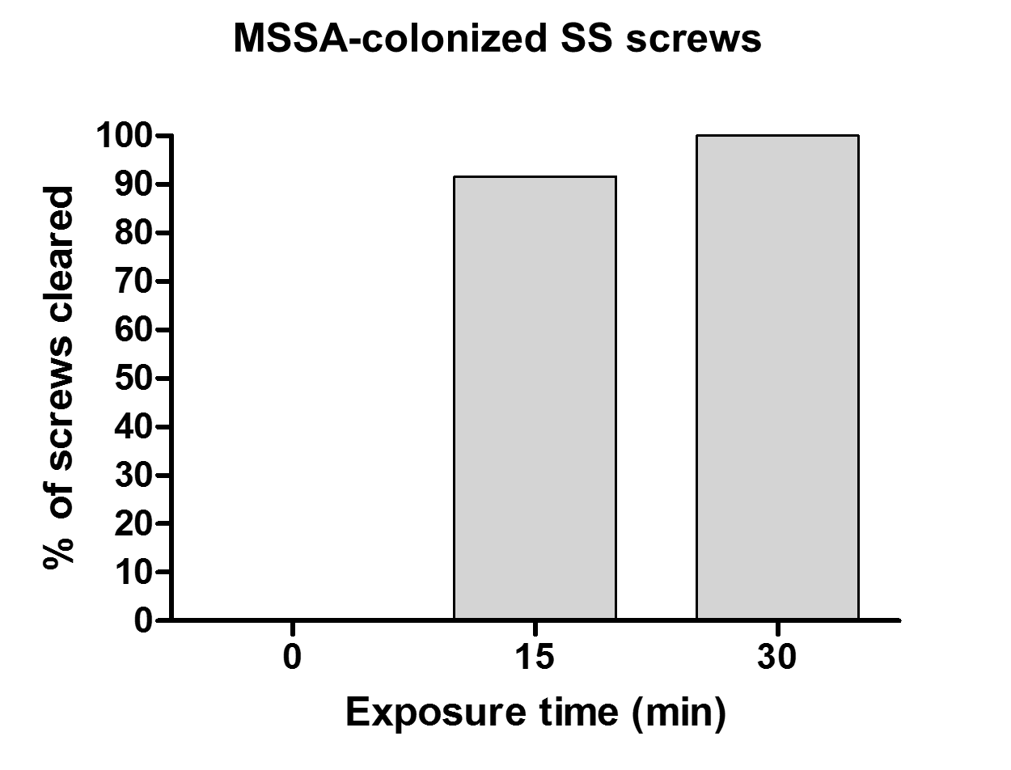

Figure 3

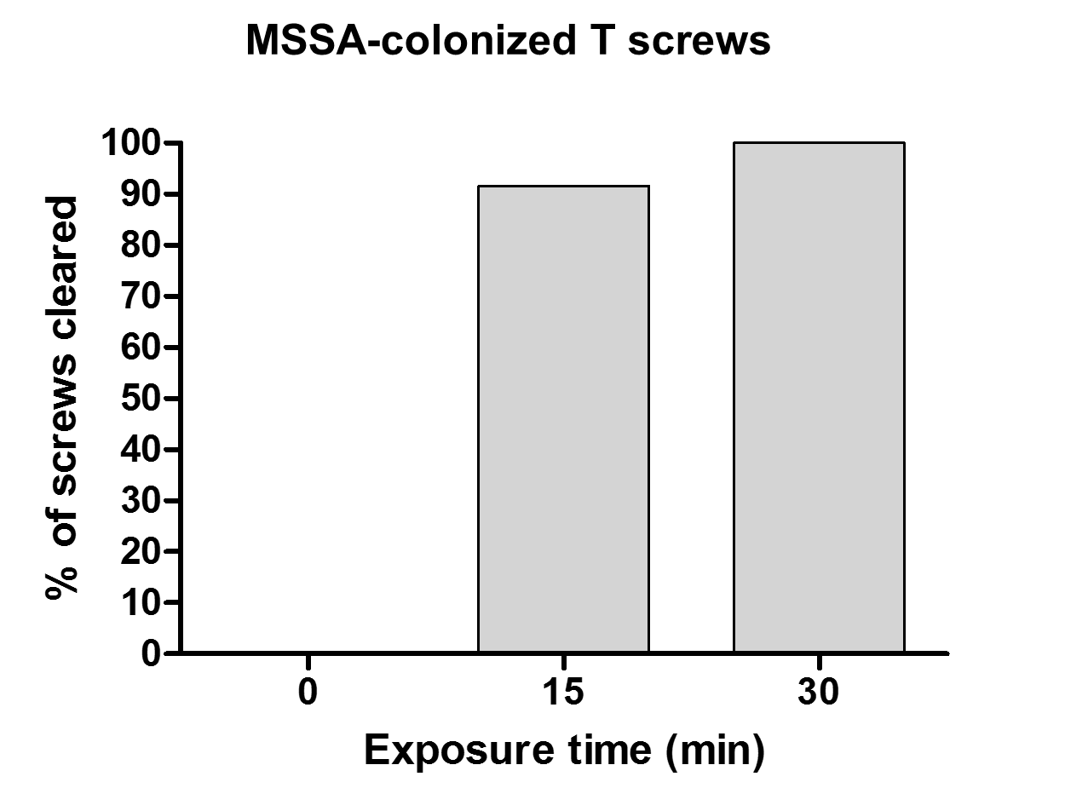

Figure 4

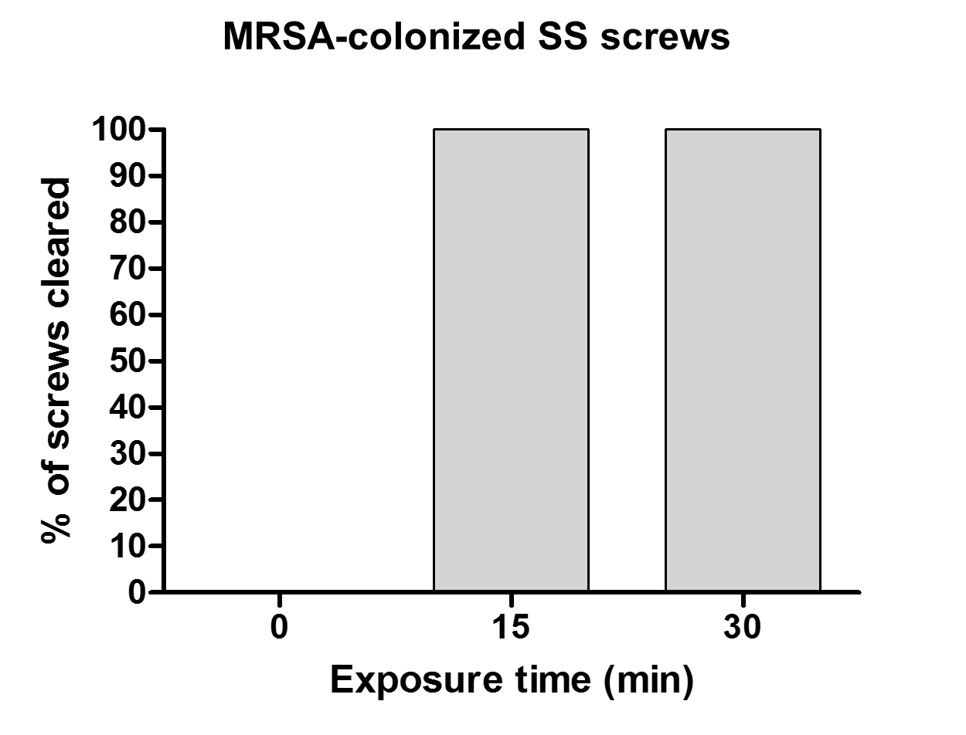

Figure 5

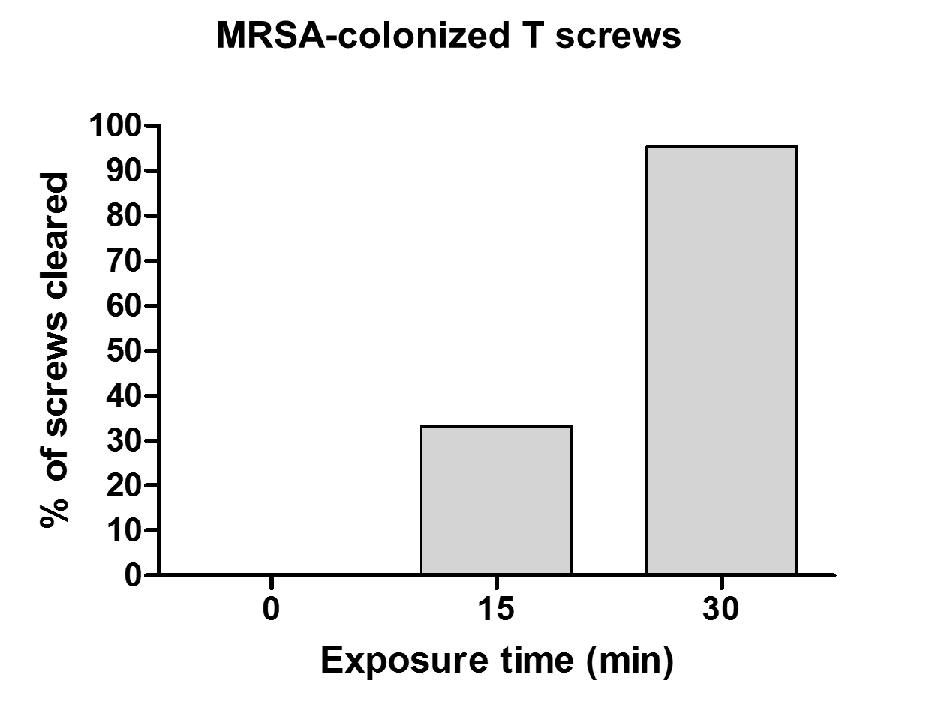

Figure 6