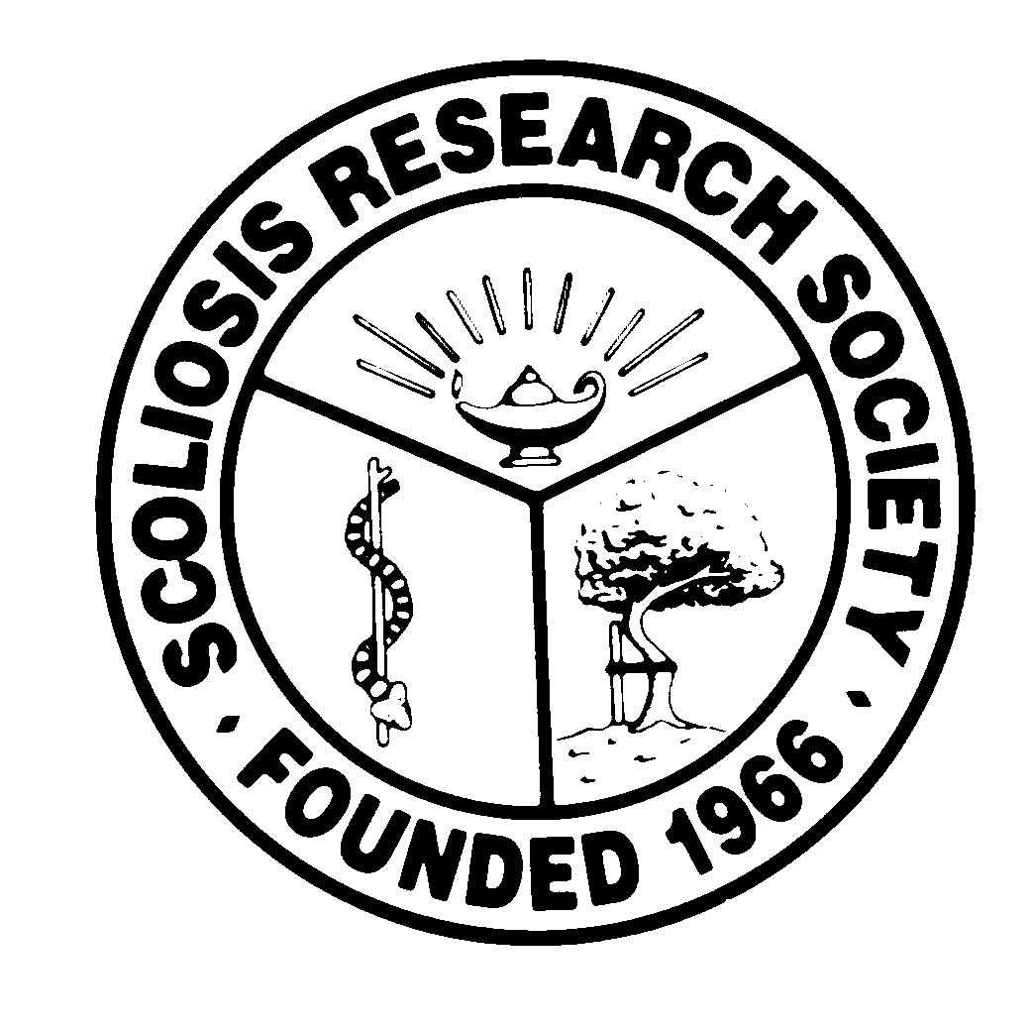
Scoliosis Research Society
Educational Activity Proposal
Please fax or email this form to Courtney Kissinger
at (414) 276-3349 or ckissinger@srs.org
Name: Ripul Panchal

Email: ripulpanchal@gmail.com Phone: 630.865.5425

Type of Activity:

Annual Meeting
Pre-Meeting Course Half Day Course Lunchtime Symposium

Other (Please Specify):

Activity Title: Spinal Deformity – Preventing and Managing Complications

Activity Chair
Please list additional proposed faculty:
- Need input
Please list proposed faculty:

Activity Description:
- Instrumentation Failure – Rod/screw break/pullout, Implant migration
- CSF leak – Acute versus Delayed
- Wound dehiscence/infection
- Inadequate correction
- PJK/DJK
- Biologics/pseudoarthrosis
- Monitoring
- Medical – PNA, DVT/PE, Blindness, Coagulopathy, and etc.

What do you hope to accomplish by offering this activity? What problems in patient care or other work related to the practice of medicine do you hope to address?
- Identify various complications of spinal deformity surgery.
- Inform appropriate managements options of common complications.
- To minimize sequela of intraop and postoperative complications.

After this activity has been completed, what steps will be taken to reinforce the education presented? How will an improvement in clinical practice be assessed?
- Survey

