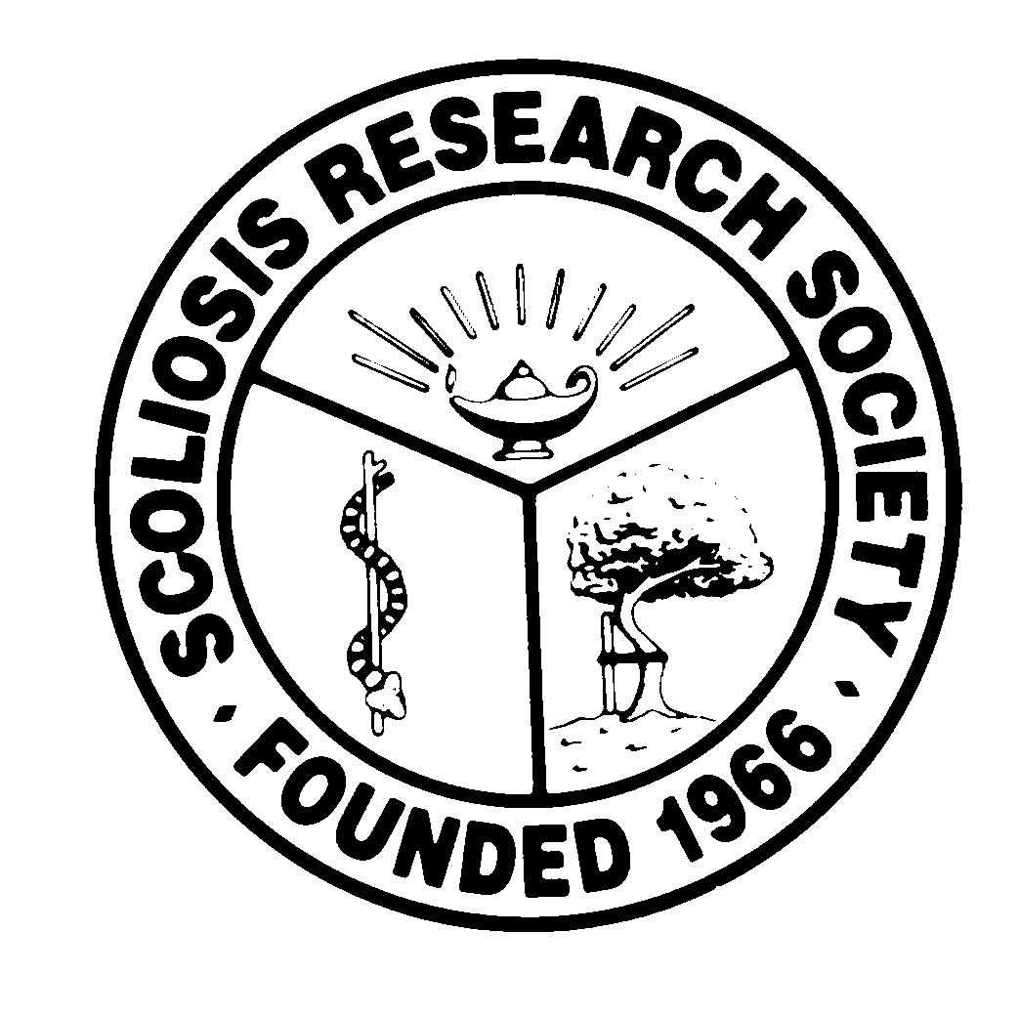
Scoliosis Research Society
Educational Activity Proposal
Please fax or email this form to Courtney Kissinger
at (414) 276-3349 or ckissinger@srs.org
Name: Sigurd Berven

Email: Bervens@orthosurg.ucsf.edu

Type of Activity:

Annual Meeting:
Pre-Meeting Course X Half Day Course X Lunchtime Symposium

Other (Please Specify):

Activity Title Complications in Spinal Deformity Surgery

Activity Chair: Sigurd Berven
Please list additional proposed faculty:
Marinus DeKleuver
David Polly
Michael Daubs
Chris Shaffrey
Praveen Mummaneni
Rajiv Sethi
Please list proposed faculty:

Activity Description:

Complications are an important component of risk of surgery, and understanding complications is essential for informed choice. This program will review complications in pediatric and adult deformity surgery with the purpose of discussing the expected incidence of specific complications, techniques to avoid specific complications, and the impact of complications on outcomes.
The purpose of the paper is to guide an evidence-based approach to safe spine surgery.

What do you hope to accomplish by offering this activity? What problems in patient care or other work related to the practice of medicine do you hope to address?

This session will be inclusive of pediatric and adult deformity. The purpose of the activity is to guide an evidence-based approach to safety and quality in spine surgery. Recognizing expected rates of complications, and comparing observed and expected rates is the foundation for quality improvement efforts. This program will guide efforts of surgeons to improve quality of care and encourage learning from the experiences of centers around the world.

After this activity has been completed, what steps will be taken to reinforce the education presented? How will an improvement in clinical practice be assessed?

This program will give guidance on the development of perioperative pathways and protocols for appropriate care. Folllow-up surveys may be used to assess improvements of changes in practice.

