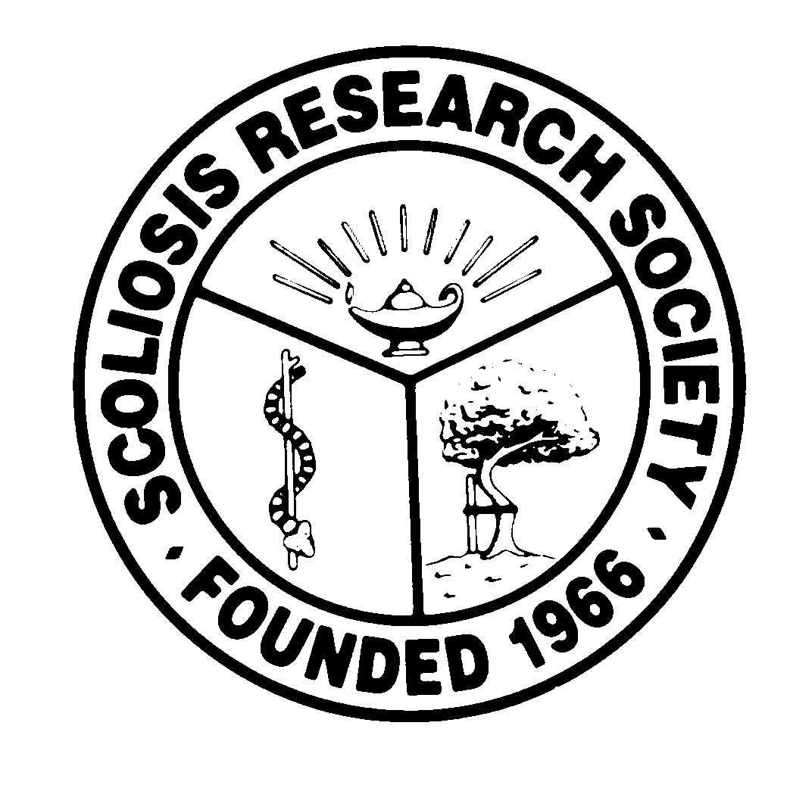
Scoliosis Research Society
Educational Activity Proposal
Please fax or email this form to Courtney Kissinger
at (414) 276-3349 or ckissinger@srs.org by November 1st.
Name: Ram Mudiyam M.D.,MBA

Email: rmudiyam@gmail.com Phone: 714-655-4250

Type of Activity:

Annual Meeting
Pre-Meeting Course Half Day Course Lunchtime Symposium

Other (Please Specify):

Activity Title: Shared Decision Making in Adult Spinal Deformity Surgery

Activity Chair: Ram Mudiyam M.D.,MBA
Please list additional proposed faculty: 1. Evalina Burger M.D. 2. Marinus de Kleuver M.D. 3. Jonathan Sembrano M.D. 4. Sig Berven M.D.
Please list proposed faculty:

Activity Description: Adult spinal deformity surgery presents several decision making challenges due to high complication rates, varying etiologies and psychosocial variances. A recently concluded SRS survey showed that 64% of respondents were very interested in the SRS developing shared decision making tools for adult deformity surgery. The symposium will trace the history of SDM, its current application in other medical specialties and development of decision aids specifically to address complex adult deformity cases.

What do you hope to accomplish by offering this activity? What problems in patient care or other work related to the practice of medicine do you hope to address?

The goal is to create a collaborative process via shared discussions of medical evidence and patient preferences leading to more relevant informed consents.

After this activity has been completed, what steps will be taken to reinforce the education presented? How will an improvement in clinical practice be assessed?

A post symposium survey will be generated to assess the value of decision aids. Would suggest a task force on informed consent be formed to further advance this topic.

