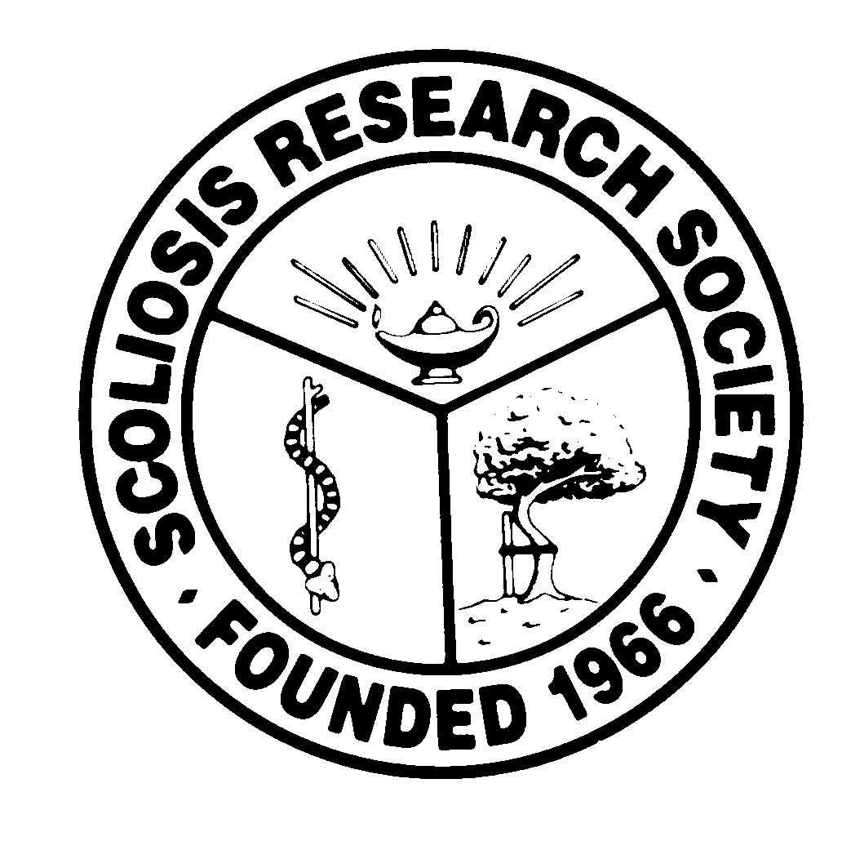
Scoliosis Research Society
Educational Activity Proposal
Please fax or email this form to Courtney Kissinger
at (414) 276-3349 or ckissinger@srs.org

Name: Olavo Biraghi Letaif

Email: oletaif@gmail.com Phone: +55 (11) 99907-9944

Type of Activity:

Annual Meeting
Pre-Meeting Course X Half Day Course X Lunchtime Symposium

Other (Please Specify):

Activity Title: Getting your deformity paper published

Activity Chair:
Please list additional proposed faculty: I suggest faculties that are currently reviewers of major impact journal like: Spine; Eur Spine Journal; Journal of Pediatrics Orthopedics; Spine Journal; Spine Deformity etc
Please list proposed faculty:

Activity Description:
- Current topics/Hot topics in spine deformity research
- Ideal model for a deformity paper
- Tips to get your paper published – reviewers perspective
- Tips and advices for non-native English speakers who want to publish in English
- Most common mistakes when writing and structuring a deformity paper

What do you hope to accomplish by offering this activity? What problems in patient care or other work related to the practice of medicine do you hope to address?
I hope this activity educates researchers on how to produce better quality studies and scientific works. I also expect that such activity might encourage different surgeons, including non-north American based surgeons, to get their papers published and their work debated. Considering SRS proposal of internationalization, this activity might offer a chance to educate surgeons and improve outcomes.

After this activity has been completed, what steps will be taken to reinforce the education presented? How will an improvement in clinical practice be assessed?
- SRS can monitor papers that are presented to evaluation in Spine Deformity journal – age of the researchers and their working country
- SRS can display on their site some high impact published papers and can technically comment on their strengths, possible weaknesses, bias and methodology

