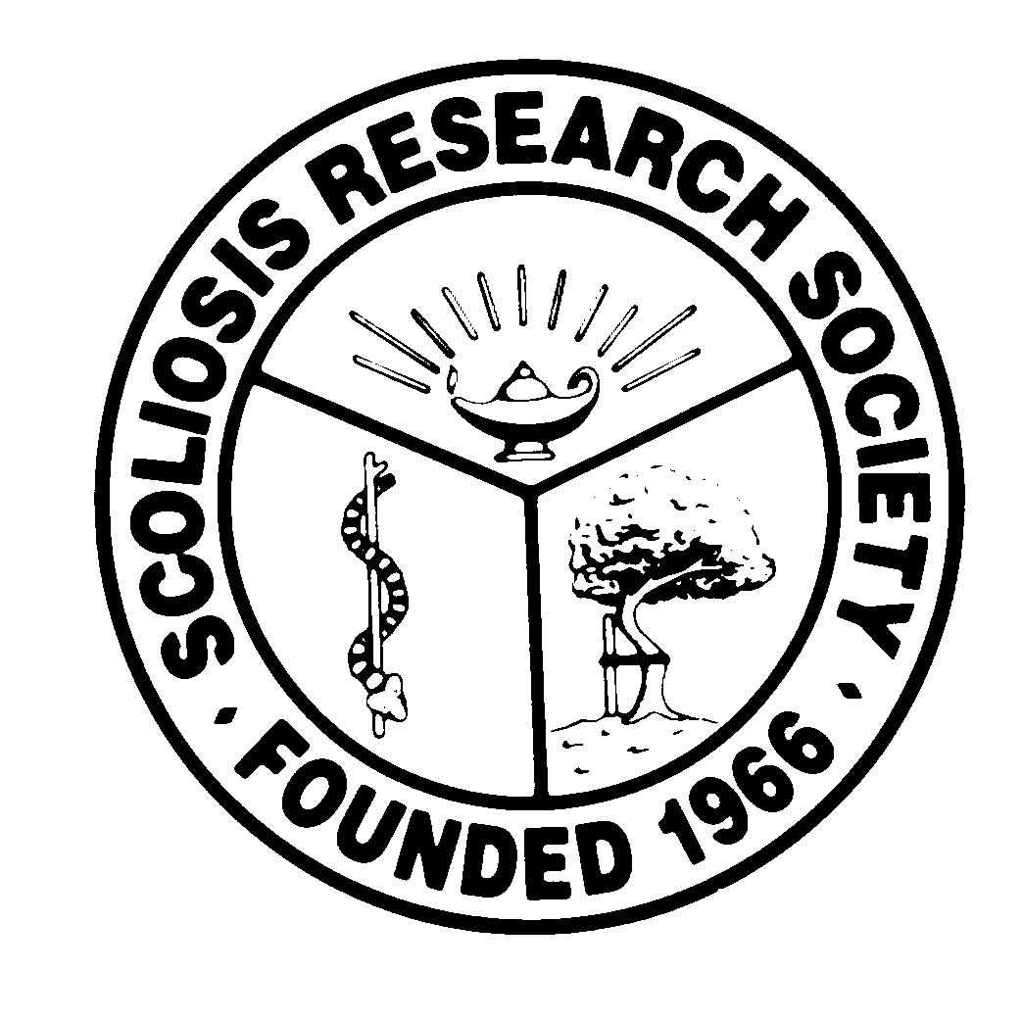
Scoliosis Research Society
Educational Activity Proposal
Please fax or email this form to Courtney Kissinger
at (414) 276-3349 or ckissinger@srs.org
Name: Charles H Crawford III, MD

Email: chcraw01@gmail.com Phone: 502-608-7202

Type of Activity:

Annual Meeting
Pre-Meeting Course Half Day Course Lunchtime Symposium

Other (Please Specify):

Activity Title: Global Spine Care – Past, Present, and the Future

Activity Chair: TBD
Please list additional proposed faculty:
From each Major Spine Center – a Senior and Junior Attending to speak
North America: 2 or 3 centers? Europe: 2 or 3 centers? Asia: 2 or 3 centers? South America? Other?
Please list proposed faculty:

Activity Description: An overview of the evolution of spine care at major spine centers. Lessons from the past, current “state of the art,,” and future directions. “Senior” attending would start with past and present and “Junior” attending could speak about present and future.

What do you hope to accomplish by offering this activity? What problems in patient care or other work related to the practice of medicine do you hope to address?

Essentially, a virtual “visiting surgeon” program where the audience can learn lessons from major spine centers around the world. “pearls” of wisdom. Similarities and differences in the past, present and future of spine care at major world centers (centers well represented by SRS members)

After this activity has been completed, what steps will be taken to reinforce the education presented? How will an improvement in clinical practice be assessed?

Changes in practice assessed through CME surveys.

