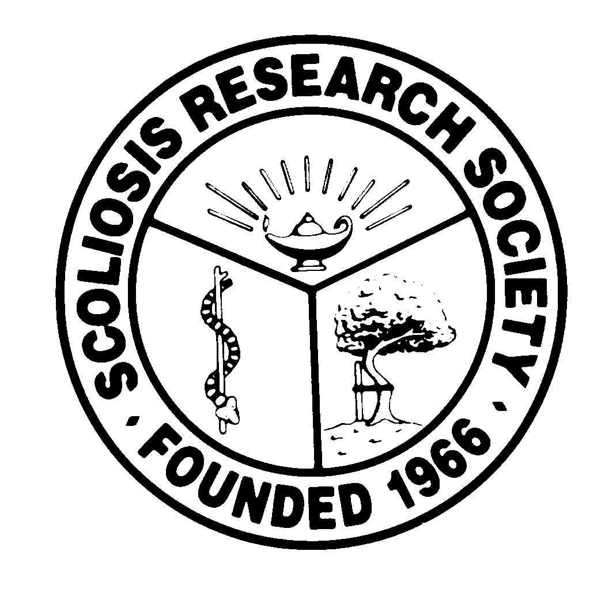
Scoliosis Research Society
Educational Activity Proposal
Please fax or email this form to Courtney Kissinger
at (414) 276-3349 or ckissinger@srs.org
Name: Charles H Crawford III, MD

Email: chcraw01@gmail.com Phone: 502-608-7202

Type of Activity:

Annual Meeting
Pre-Meeting Course Half Day Course Lunchtime Symposium

Other (Please Specify):

Activity Title: Evolution of Pre-op, Intra-op and Post-op Protocols

Activity Chair: TBD
Please list additional proposed faculty:
SRS member from each Major Spine Center (number of centers depends on length of program/session)

Please list proposed faculty:

Activity Description: An overview of the evolution of protocols at major spine centers

Pre-op – the most significant improvement in the last 5 years
Intra-op – the most significant improvement in the last 5 years
Post-op – the most significant improvement in the last 5 years

What do you hope to accomplish by offering this activity? What problems in patient care or other work related to the practice of medicine do you hope to address?

Essentially, a virtual “visiting surgeon” program where the audience can learn lessons from major spine centers around the world. “pearls” of wisdom. Similarities and differences in the pre-op, intra-op, and post-op protocols (centers well represented by SRS members)

After this activity has been completed, what steps will be taken to reinforce the education presented? How will an improvement in clinical practice be assessed?

Changes in practice assessed through CME surveys.

