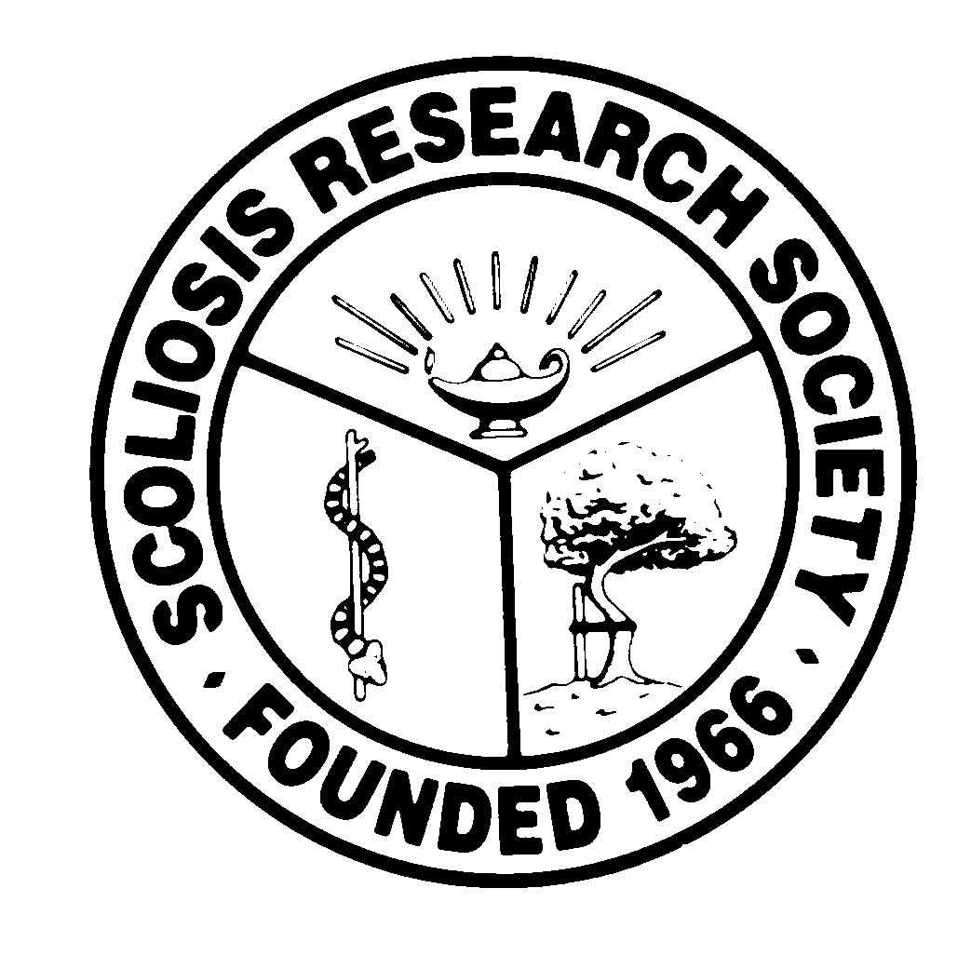
Scoliosis Research Society
Educational Activity Proposal
Please fax or email this form to Courtney Kissinger
at (414) 276-3349 or ckissinger@srs.org
Name: Richard Gross

Email: grossrh@mac.com Phone: 843-327-3491

Type of Activity:

Annual Meeting
Pre-Meeting Course Half Day Course x Lunchtime Symposium

Other (Please Specify):

Activity Title: Assessment and Management of Sagittlal Deformtiy

Activity Chair: Richard Gross
Please list additional proposed faculty: Virginia Lafage, Sig Berven, , Muharrem Yazici, JM Mac-thiong
Please list proposed faculty:

Activity Description: The role of sagittal alignment is increasingly acknowledged as a dominant factor in outcomes of surgical intervention for deformity. Spinopelvic factors have long been acknowledged but head and shoulder position and postural factors also have an important role. Surgical strategies to prevent proximal junctional kyphosis or failure have evolved in recent years..

What do you hope to accomplish by offering this activity? What problems in patient care or other work related to the practice of medicine do you hope to address? Increase awareness of postural factors in outcomes for management of kyphotic deformity, strategies to improve proximal fixation and reduce PJK.

After this activity has been completed, what steps will be taken to reinforce the education presented? How will an improvement in clinical practice be assessed? That is a difficult charge. A post symposium questionnaire could assess the immediate impact ; perhaps a folllowup questionnaire 6 months after the meeting would provide some information on whether there was any lasting impact of the symposium

