**Locally Applied Simvastatin as an Adjunct to Promote Spinal Fusion in Rats**

Sravisht Iyer1, Patrick, E Donnelly1, George Spaniel1, *Matthew E. Cunningham1*

*1*Hospital for Special Surgery, New York-United States

**ABSTRACT**

**Summary**

We were able to successfully validate that sustained release of Simvastatin (SIM) via a PLGA nano particle (NP) SimNP was able to induce an increase in mineralization as well as an increase in markers of bone formation. Rats treated with SimNP had more bone formation on X-ray (XR) and were significantly more likely to achieve fusion. Our findings highlight the potential of simvastatin as a safe, cost-effective bone anabolic agent for use in spinal fusion surgery.

**Hypothesis**

Sustained, local delivery of SIM would assist with spinal fusion in a rat animal model

**Design**

Animal study

**Introduction**

Despite data showing the bone-anabolic properties of statins in fracture healing, no studies that have evaluated the impact of locally delivered statins on spinal fusion.

**Methods**

Blank PLGA (BlankNP) and SIM-loaded PLGA (SimNP) nanoparticles were created by adapting established techniques. SimNP, ranging from 217ug/mL to 883ug/mL, was placed in 15mL of PBS at 37ºC with agitation. SIM release was measured for 15d using an UV spectrophotometer. In vitro validation was performed using MC3T3-E1 osteoblast precursor cells were cultured in complete (COMP) or mineralizing (MIN) media. A posterior spinal fusion model was utilized in 40 male 12wk old outbred Wistar rats. Rats were treated with BlankNP, SimNP (15 rats each) or SIM drug (10 rats). XR to assess bone formation were obtained at 4wks and 9wks after surgery. Spines were explanted at 9wks and a manual assessment of fusion (MAF) was performed by three blinded observers.

**Results**

SimNP successfully achieved sustained release over two weeks with ~50% occurring in the first day. Release efficiency averaged 74.1%. MC3T3 cells cultured with SimNP at 200ug/mL had higher expression of OCN and OPN at 1wk and 2wks. Cells cultured with SimNP showed more deposition of calcium as assessed by alizarin staining at 1wk and 3wks. Three animals (one from each group) were sacrificed due to post-operative complications (paralysis x2, infection). The remaining animals were analyzed. We found no significant differences between the BlankNP and SIM drug rats in XR scores or MAF. Compared to BlankNP, SimNP treated rats had significantly higher XR scores at 4wks (3.0 vs. 1.9, p=0.010) and 9wks (3.6 vs. 1.8, p<0.001) (Figure). Compared to SIM drug, SimNP rats had similar XR scores at 4wks but higher scores at 9wks (3.6 vs 2.1, p=0.005). MAF showed that SimNP had a significantly higher fusion rate than BlankNP (42.9% vs. 0%, p=0.006).

**Conclusion**

Rats treated with SimNP had significantly more bone formation on XR and were significantly more likely to achieve fusion judged by MAF compared to control animals (BlankNP).

**INTRODUCTION**

Achieving a solid fusion is crucial to achieving stable, long-term following a number of spine surgery procedures.1–3 Surgeons employ several different strategies to help achieve this goal. These include: local and iliac crest autograft, allograft bone, bone graft extenders such as synthetic ceramics and recombinant bone morphogenetic protein-2 (BMP-2).4–6 While allograft bone and bone graft extenders provide an osteoconductive environment, iliac crest autograft and BMP-2 are the only osteoinductive options currently available to surgeons.

Both options, however, suffer from significant limitations. Iliac crest autograft has been associated with donor site morbidity, increased operating time, increased blood loss and a longer hospital stay.2 BMP-2 can help circumvent several of these limitations; several well-designed studies have shown that patients treated with BMP-2 achieve similar long-term outcomes and fusion rates as patients receiving iliac crest autograft.7,8 Unfortunately, BMP-2 is expensive9,10 and has been linked to complications such as wound problems, post-operative leg pain, ectopic bone formation and retrograde ejaculation.11–15

Despite these limitations, BMP-2 is widely used in spine surgery and its use has grown consistently over the past decade.16 The widespread adoption of BMP-2 in the face of these limitations highlights the demand for bone-anabolic (osteoinductive) molecules in spine surgery. There is a clearly a need for a safe, cost-effective, anabolic molecule that can assist with spinal fusion but avoid the side-effects associated with the use of BMP-2.17

Several years ago, investigators showed that statins (HMG CoA-reductase inhibitors) could stimulate osteoblast formation and have a bone-anabolic effect.18 The anabolic effect of statins is believed to be mediated by the same pathways as BMP-2.18,19 Because BMP-2 associated complications are a dose-dependent phenomenon,11,12 a more moderate upregulation of this pathway via statin administration may represent an ideal therapeutic approach. In addition to their action through BMP-2, statins may also prevent osteoblast apoptosis by activation of the TGFbeta/Smad3 pathway.20

These *in vitro* data have been corroborated in number animal models for fracture healing and the reduction of periprosthetic bone loss.20–26 There is, however, relatively little literature examining the impact of statins in promoting bone formation after spine surgery. Previous attempts have focused on oral administration,26,27 a strategy that is fundamentally limited given the drug’s high first-pass metabolism in the liver and low bioavailability in the bone.21,22

We sought to address these shortcomings by developing a device to enable local delivery of simvastatin to the spine and to determine the impact of locally delivered simvastatin on spinal fusion in a rat model.We hypothesized that we could successfully deliver simvastatin to the spine using a poly(lactic-co-glycolic acid) (PLGA) nanoparticle and that the use of these nanoparticles would result in increased bone formation and fusion rates.

**METHODS**

**Nanoparticle Preparation**

We adapted previously described methods24 to design PLGA nanoparticles. In brief, 120mg of PLGA was added in 2.4mL of chloroform. This solution was sonicated for 2 min at 30W, immediately added to 24 mL of a 2% polyvinyl alcohol (PVA) solution in water and sonicated again at 30W for 30s yielding an opaque, white suspension. Chloroform was removed under reduced pressure and the particles were centrifuged at 3000 RPM for 5 minutes, the nanoparticles were isolated and lyophilized. Nanoparticles were stored at -80°C. Two types of nanoparticles were made – blank nanoparticles (BlankNP) containing only PLGA and simvastatin-loaded nanoparticles (SimNP) containing both simvastatin and PLGA. To fabricate SimNP, 12mg of simvastatin (SIM; Sigma Aldrich, St Louis, Mo) was added to the initial PLGA-chloroform solution.

**Characterization of the Nanoparticles**

*Electron Microscopy:* Nanoparticles were dispersed in methanol, the mixture was then pipetted onto scanning electron microscopy (SEM) sample stubs and the methanol was allowed to evaporate before being coated with carbon. Nanoparticles were characterized using a Zeiss EVO 50 scanning electron microscope operating in low-vacuum mode at an acceleration voltage of 15.0 keV using the backscatter detector. Nanoparticle diameters were measured using ImageJ software, 100 measurements were taken of individual particles and reported as the average.

*Sustained Release:* Simvastatin release over time was measured using an ultraviolet spectrophotometer at 247.2nm **(Figure 1a**). The wavelength was chosen because PLGA, phosphate buffered saline (PBS), and ethanol did not interfere with the abosrbance at 247.2nm. Simvastatin in ethanol and PBS was used as a standard ranging from 5-100uM (**Figure 1b**). SimNP, ranging from 217ug/mL to 1667ug/mL, was placed in 15mL of PBS at 37° C with agitation. Aliquots (0.5mL) were removed at each timepoint to measure simvastatin concentration.

**In Vitro Tests**

MC3T3-E1 (ATCC, Manassas, VA) osteoblast precursor cells were cultured in complete or mineralizing media. Complete media consisted of DMEM with 10% fetal bovine serum (FBS) and 1% 100X antibiotic/antimycotic (ThermoFisher Scientific, Waltham, MA). Mineralizing media was complete media with 0.5M beta-glycerol phosphate, 50mM vitamin C and 1nM dexamethasone.

Cell viability assays were performed in a 96-well plate using an MTS Cell Proliferation Colorimetric Assay Kit (BioVision, Milpitas, CA) with absorbance quantified at 490nm. SIM drug doses ranged from 1 to 16ug/mL and SimNP doses ranging from 25 to 200ug/mL.

Deposition of calcium was measured using an alizarin stain at 1 and 3 weeks. Cells were cultured in one of the following conditions: (1) complete media (COMP), (2) mineralizing media (MIN), (3) MIN plus 88 ug/mL SimNP, (4) MIN plus 166ug/mL SimNP, (5) MIN plus 8ug/mL SIM and (6) MIN plus 16ug/mL SIM. After 1 or 3 weeks, the culture medium was removed from each well and gently washed 3 times with 1x PBS. The cells were then fixed in 10% buffered formalin for 15 minutes at room temperature. The fixative was then removed using 3 washes with diH20. The diH20 was removed and 1 mL of 40mM alizarin red stain was then added to each well. The plates were then incubated at room temperature for 20-30 minutes and washed again with diH20 to remove all dye. Images were then taken using a digital camera to provide a qualitative measure of calcium deposition.

Cells were cultured for 7 or 14 days in one of the following conditions: (1) MIN, (2) MIN plus 4ug/mL SIM, (3) MIN plus 8ug/mL SIM, (4) MIN plus 100ug/mL SimNP, and (5) MIN plus 200 ug/mL SimNP. Total cellular mRNA was extracted at 7 and 14 days. Osteoblast differentiation and bone formation was quantified using a real-time PCR system to measure expression of osteocalcin (OCN) and osteopontin (OPN) with specific primers. The primers were designed as follows: OCN forward 5’-AAGCAGGAGGGCAATAAGGT- 3’ and reverse 5’- GAGATTTGCTTTTGCCTGTTTG- 3’; OPN forward 5’-AGCTGCAAGAGACACCCTTTG-3’ and reverse 5’- TGAGCTGCCAGAATCAGTCACT-3’.

**In Vivo Tests**

A model of posterior spinal fusion was utilized in 40 male 12 week old outbred Wistar rats. Briefly, a midline posterior skin incision was followed by two separate paramedian fascial incisions to expose the transverse processes (TP) of L4 and L5. The TP were decorticated. Corticocancellous bone was harvested from each iliac wing, morselized and implanted bilaterally with one of three treatments (BlankNP, SimNP or SIM only) to bridge the L4 and L5 TP. Treatments were assigned randomly using a random number generator. The groups were as follows: Blank NP (15 rats), SimNP (15 rats) or SIM drug (10 rats). Dosing of each treatment arm was as follows: 100-200mg/kg BlankNP, 100-200mg/kg SimNP and 10-20mg/kg SIM drug. Dosing for SIM drug was based on the prior literature28–32 and the SimNP dosing was calculated based on our *in vitro* release profiles so that we would achieve roughly the same total dose of SIM release.

X-rays to assess for bone formation were obtained at 4 weeks and 9 weeks after the date of surgery. X-rays were scored by three blinded observers using a previously-described six point scale (0: no bone formation, 1: < 25% bone filling, 2: 25-<50% bone filling, 3: 50-<75% bone filling, 4: 75-99% bone filling, 5: clear evidence of successful fusion).33 The average of the three observers’ scores was used for analysis. Interobserver reliability was calculated using intraclass correlation (ICC).34

Animals were sacrificed at 9 weeks. Spines were then explanted and a manual assessment of fusion was performed by three blinded observers checking for motion at L4-5 compared to the levels above and below. Spines were considered fused if 2 of 3 observers considered the spine fused. ICC for the MAF was also performed.

Sacrificed spines were fixed with 10% buffered formalin and sent for micro computed tomographic (uCT) analysis. Qualitative analysis of the uCT images was performed. Three spines from each group were then decalcified with EDTA and 2 micrometer thick sections through the fusion mass were obtained using a microtome. Sections were stained using hematoxylin and eosin (H&E) and Safranin O. A qualitative examination of bone morphometry was performed using a light microscope.

**RESULTS**

**Nanoparticle Characterization**

Under electron microscopy, SimNP averaged 208±128.7nm in diameter ranging in size from 29.4 to 549nm (**Figure 2**). UV-Vis When SimNP were placed in solution with PBS, we saw time-dependent release over a two-week period (**Figure 3**). Approximately 50% of the total elution occurred within the first day followed by a slower release over the remainder of the two-week interval. Total release efficiency averaged 74.1%. As the concentration of SimNP in PBS was increased, the total drug released also increased in a roughly linear fashion.

**In Vitro Response**

MC3T3 cells showed no reduction in cell viability at SIM concentrations ranging from 1-16 ug/mL or with SimNP doses ranging from 12.5 to 200 ug/mL. Cells cultured with SIM showed significantly more calcium deposition on Alizarin red staining (**Figure 4**). PCR showed significantly more expression of osteopontin and osteocalcin at 7 and 14 days in MC3T3 cells treated with Simvastatin and with SimNP (**Figure 5**). Although all SIM treated groups showed increased expression of OCN and OPN, there did not appear to be a clear dose-dependent relationship with regards to expression.

**In vivo response**

*Complications*

Three animals were sacrificed post-operatively, 2 for paralysis (1 each in SimNP and BlankNP) and 1 due to deep infection (SimNP). In addition, 11 animals required oral antibiotics in their feed for superficial infections (5 in the blank NP group, 4 in the SimNP group and 2 in the SIM drug group). The risk of infection did not differ by group (BlankNP 33.3%, SimNP 26.7%, SIM drug 30%).

*X-ray scores*

There was substantial to almost perfect agreement between raters for 4 week and 9 week x-rays (ICC: 0.8 and 0.75, respectively).34 Compared to Blank NP, SIM NP treated rats had significantly higher XR scores at 4 wks (3.0 vs. 1.9, p=0.010) and 9 wks (3.6 vs. 1.8, p<0.001). There was no difference between the SIM NP and SIM drug rats at 4 wks but SIM NP rats had a higher XR score at 9 wks (3.6 vs 2.1, p=0.005) (**Figure 6**).

*Manual Assessment of Fusion*

There was substantial agreement between raters for manual assessment of fusion (ICC = 0.73). Spines that were fused had a significantly higher XR score compared to spines that were considered unfused (4.7±0.8 vs. 2.1±0.9, p < 0.001). SimNP rats had the highest fusion rate (42.9%) and this rate was significantly higher than BlankNP (0%, p=0.006) (**Table 1**). There was no difference between the fusion rates for SIM drug and BlankNP (22.2% vs. 0%, p=0.065).

*Qualitative analysis*

Qualitative analysis of the uCT images showed that the SIM-treated animals formed significantly more bone and a more mature fusion mass (**Figure 7**). Histologic slides showed evidence of new bone formation with active remodeling.

**DISCUSSION**

Statins have long been used as potent inhibitors of cholesterol biosynthesis and have a well-established role in lowering the risk of coronary artery disease.35 More recently, statins were found to have a bone anabolic effect. Mundy and colleagues18 first published a report in 1999 of a drug screen searching for small molecules that would activate the promoter of the BMP-2 gene. In a screen of over 30,000 compounds, they identified lovastatin as specifically increasing the activity of the BMP-2 promoter as characterized by a firefly luciferase reporter gene. The investigators then conducted both *in vitro* and *in vivo* experiments using murine calvaria and, upon injection of various forms of statins, found an increase in new bone formation similar to that seen after treatment with FGF-1 and BMP-2.18

These findings have spurred significant research interest, and subsequent work has elucidated the mechanism by which statins may assist in new bone formation.18–22,36 The current thought is that statins function both by increasing osteoblast differentiation and interfering with osteoclast function. The anabolic effect of statins is believed to be mediated primarily by activation of MAPK and upregulation of the BMP-2 and Runx2 pathway.18 In acting through this pathway, statins have been shown to induce osteoblast differentiation. Treatment of cells with BMP-2 antagonists (noggin) significantly reduces the osteogenic effect of lovastatin, for example.19 In addition to their action through BMP-2, evidence exists to suggest that statins may also prevent osteoblast apoptosis by increasing the level of Smad3 and thereby activating the TGFbeta/Smad3 pathway.20

Statins may also prevent osteoclastogenesis by inhibiting the action of farnesyl diphosphate synthase and thereby preventing prenylation and activation of GTPase.22 Second, work in mouse bone cell cultures has found the statins increase OPG mRNA expression and decrease RANKL mRNA expression while increasing estrogen receptor expression, though the mechanisms behind these actions are not clearly understood.36

These characteristics have been shown to increase bone healing in animal models or fracture healing.30,37,38 A fracture model study in ovariectomized rats showed the benefits of local administration of simvastatin in fracture healing.30 In this study, investigators injected 5 mg/kg of simvastatin subcutaneously at the fracture site (proximal tibia) a total of three times; once on the day of the fracture and twice in the 5 days thereafter. In a comparison to sham injections, the injection of simvastatin resulted in increased volume of callus and increased mineralization on histomorphometric analysis.30 Similarly, a rat femur fracture model showed an increase in mechanical strength after local administration of simvastatin to the fracture site.37 These results have been replicated in a number of different animal studies.23–25,28,39

Despite good success with fracture healing, data in the spine is limited. The only two studies that have investigated the use of statins in the spine have been limited to oral administration of statins.26,27 The earlier of these two studies, which administered a lower dose of simvastatin (6. 5mg/kg) orally, found no difference in the quantity or quality of the fusion mass after administration of the drug.27 The results of supratherapeutic simvastatin dosing (120 mg/kg) was more encouraging, however, showing an increase in fusion rate and grade as well as increased mechanical strength of the fused levels in the treatment group.26 Such high doses of simvastatin are necessary because orally administered statins have low bioavailability and have extremely high affinity for liver cells.35

The promising results of supratherapeutic simvastatin dosing led us to investigate the impact of locally delivered simvastatin in a spinal fusion mode. We successfully validated the sustained release of SIM and showed that SimNP could induce an increase in mineralization and in markers of bone formation (OCN and OPN). There was no clear dose-response to SIM observed *in vitro*. This, however, is not inconsistent with the existing literature and might relate to the fact that high local concentrations of simvastatin can be cytotoxic.24,40 Determining the optimal dosing of SIM and SimNP, including the minimum cytotoxic dose, is an important area of future investigation. Our dosing of SIM drug *in vivo* was guided by previous research on fracture healing28–32 and the SimNP dose was calculated to roughly match this dose. We hypothesize that the sustained release of SIM by the nanoparticles results in lower local concentrations that provide the bone-anabolic effects of SIM while avoiding the cytotoxicity. Additionally, sustained release might be beneficial because bolused local delivery of the drug alone may be washed out before any meaningful bone healing can occur. We believe that this is why SimNP rats had higher XR scores compared to the SIM drug animals.

We believe our results argue strongly for further investigation into the utility of statins as an adjunct to help achieve spinal fusion. Future work involves quantification of the uCT data, determining dose-response relationships and replication of our results in a large animal model.

To our knowledge, this is the first study to demonstrate that the local delivery of simvastatin using a PLGA nanoparticle can assist in achieving spinal fusion in an animal model. Rats treated with SimNP had significantly more bone formation on XR and were significantly more likely to achieve fusion judged by MAF compared to control animals (BlankNP).

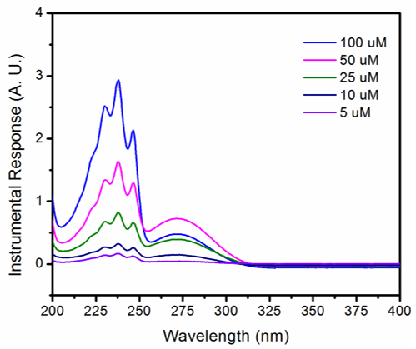

**Figure 1a.** Ultraviolet spectrophotometry profile for simvastatin solution in ethanol at various concentrations.

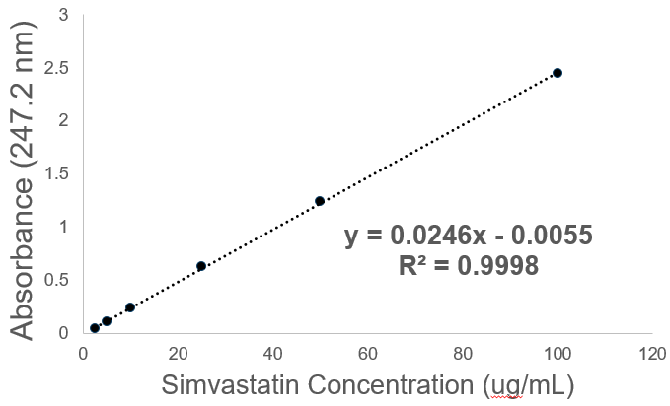

**Figure 1b.** Calibration curve showing a linear relationship between absorbance unit and simvastatin concentrations. This calibration curve was used to calculate drug release profile of simvastatin from the nanoparticles.

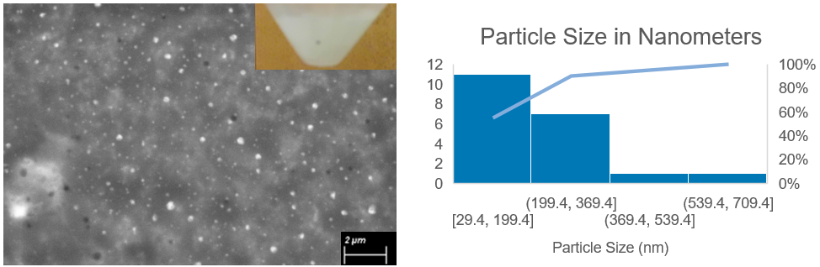

**Figure 2.** Scanning electron microscope of the simvastatin nano particles as well as the size distribution of the particles.

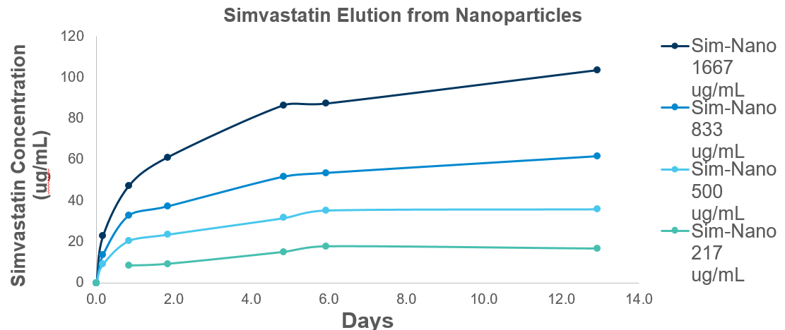**Figure 3.** Simvastatin nanoparticles were suspended in PBS at varying concentrations (217μg/mL – 1667 μg/mL) and release was measured at various time points over two weeks. Release efficiency averaged 74.2% over this time frame.

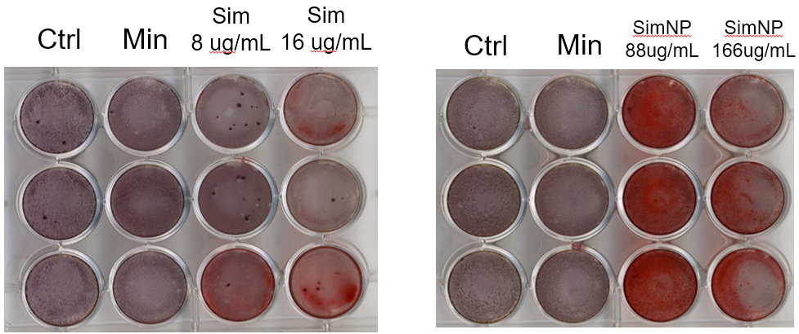

**Figure 4a**. Alizarin red staining observed after 1 week of culture in the various conditions shown. Ctrl – COMP media, Min – Mineralizing media, SIM – simvastatin drug, SimNP – Simvastatin nanoparticle.

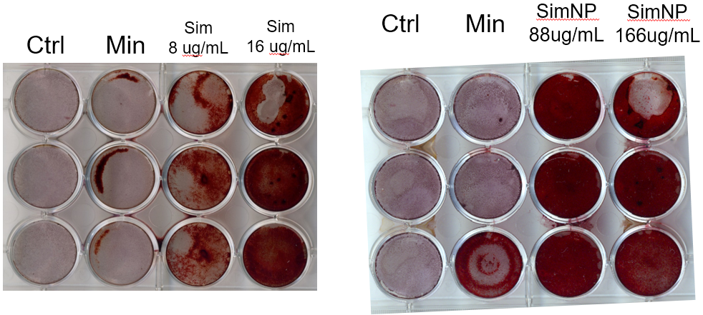

**Figure 4b**. Alizarin red staining observed after 3 weeks of culture in the various conditions shown. Ctrl – COMP media, Min – Mineralizing media, SIM – simvastatin drug, SimNP – Simvastatin nanoparticle.

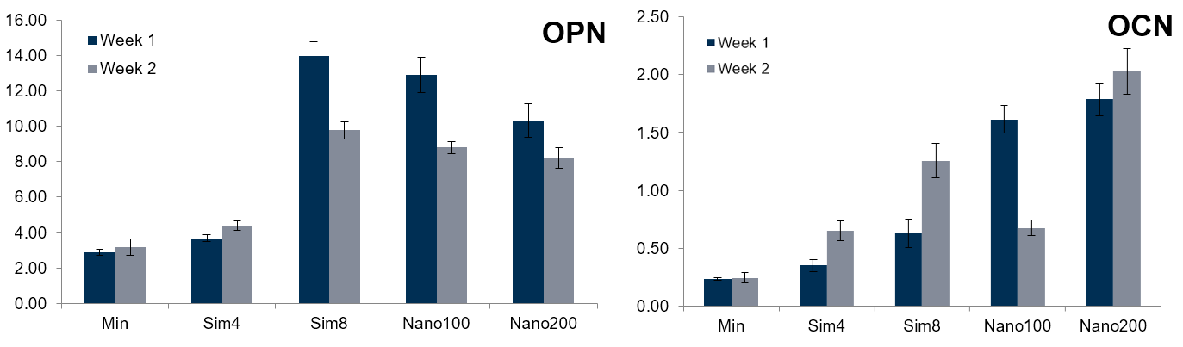

**Figure 5.** Osteopontin and Osteocalcin expression at 1 and 2 weeks after culture of MC3T3 cells in varying conditions. Although cells cultured with simvastatin showed increased expression of OPN and OCN, no clear dose-dependent response was observed. Ctrl – COMP media, Min – Mineralizing media, SIM – simvastatin drug, SimNP – Simvastatin nanoparticle.

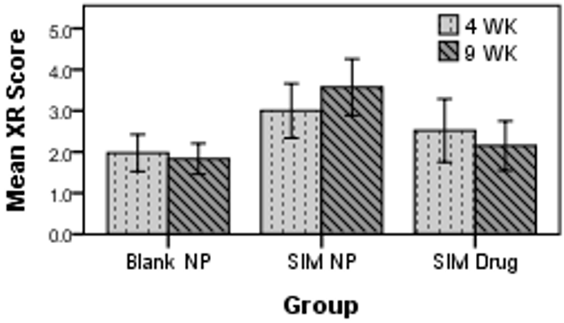

**Figure 6a.** Mean XR scores of the three blinded observes following XR performed at 4 weeks and 9 weeks. The simvastatin nanoparticle (SimNP) group had significantly higher scores than the control group (Blank NP) at 4 weeks and 9 weeks.

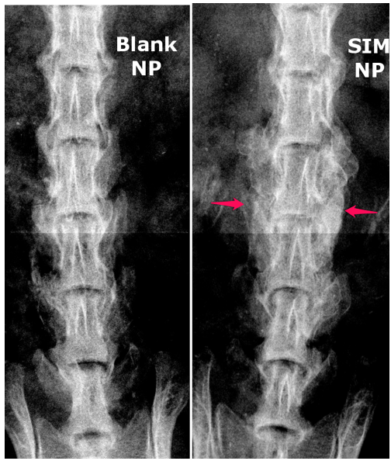

**Figure 6b.** Radiographs of a control (Blank NP) and simvastatin nanoparticle (SimNP) animal showing no significant bone formation in the control group and significant bone formation in the SimNP formation.

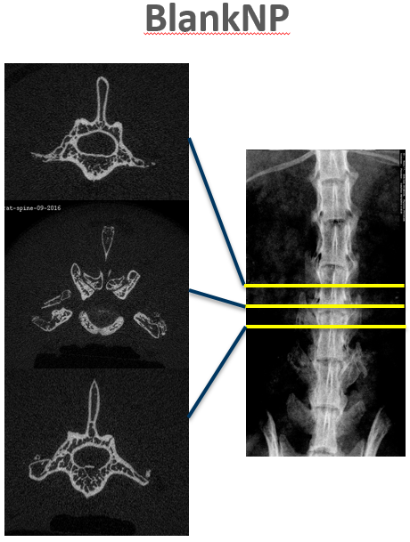

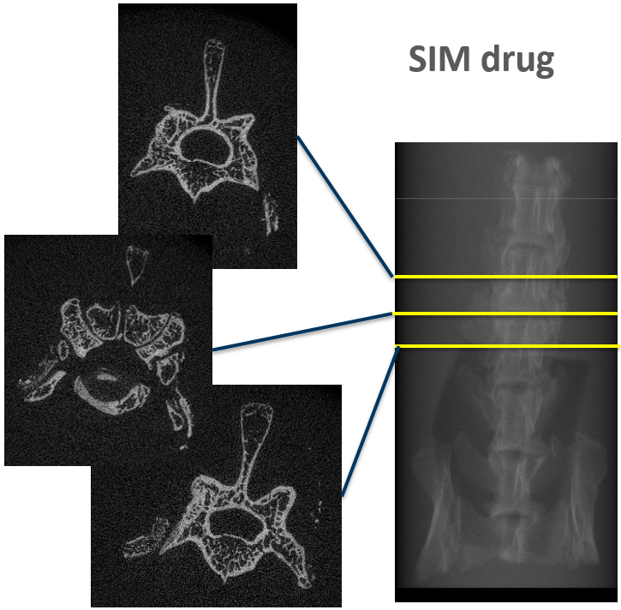

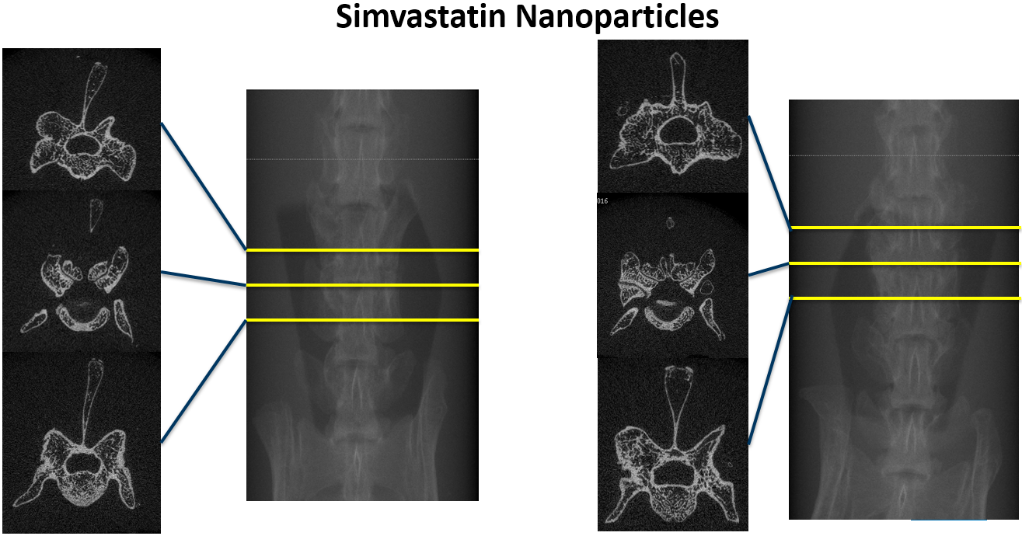

**Figure 7a-c.** Representative μCT images from the control (blank NP, a), simvastatin drug (SIM, b) and simvastatin nanoparticle (SimNP, c) treated animals. Note the significant bone formation and mature fusion masses seen in the SimNP treated animals.

|  |  |  |
| --- | --- | --- |
| **Group** | **Fusion Rate** | **P-Val** |
| BlankNP | 0% | - |
| SimNP | 42.9% | 0.006 |
| SIM Drug | 22.2% | 0.065 |

**Table 1.** Simvastatin nanoparticle (SimNP) treated nanoparticles were significantly more likely to achieve fusion at 9 weeks when assessed by blinded observers.

**REFERENCES**

1. Kornblum MB, Fischgrund JS, Herkowitz HN, Abraham DA, Berkower DL, Ditkoff JS. Degenerative lumbar spondylolisthesis with spinal stenosis: a prospective long-term study comparing fusion and pseudarthrosis. *Spine (Phila Pa 1976)*. 2004;29(7):4. doi:00007632-200404010-00004 [pii].

2. Fischer CR, Ducoffe AR, Errico TJ. Posterior Lumbar Fusion: Choice of Approach and Adjunct Techniques. *J Am Acad Orthop Surg*. 2014;22(8):503-511. doi:22/8/503 [pii].

3. Jr JAC, Dimick JB, Wainess R, Jr GRU, Chandler WF, Marca F La. Changes in the utilization of spinal fusion in the United States. *Neurosurgery*. 2006;59(1):20. doi:10.1227/01.NEU.0000219836.54861.CD [doi].

4. Grabowski G, Cornett CA. Bone graft and bone graft substitutes in spine surgery: current concepts and controversies. *J Am Acad Orthop Surg*. 2013;21(1):51-60. doi:10.5435/JAAOS-21-01-51.

5. Buser Z, Brodke DS, Youssef JA, et al. Synthetic bone graft versus autograft or allograft for spinal fusion: a systematic review. *J Neurosurg Spine*. 2016;25(4):509-516. doi:10.3171/2016.1.SPINE151005.

6. Kaiser MG, Groff MW, Watters WC, et al. Guideline update for the performance of fusion procedures for degenerative disease of the lumbar spine. Part 16: bone graft extenders and substitutes as an adjunct for lumbar fusion. *J Neurosurg Spine*. 2014;21(1):106-132. doi:10.3171/2014.4.SPINE14325.

7. 2nd JRD, Glassman SD, Burkus JK, Pryor PW, Hardacker JW, Carreon LY. Two-year fusion and clinical outcomes in 224 patients treated with a single-level instrumented posterolateral fusion with iliac crest bone graft. *Spine J*. 2009;9(11):880-885. doi:10.1016/j.spinee.2009.03.013 [doi].

8. Delawi D, Jacobs W, van Susante JLC, et al. OP-1 Compared with Iliac Crest Autograft in Instrumented Posterolateral Fusion: A Randomized, Multicenter Non-Inferiority Trial. *J Bone Joint Surg Am*. 2016;98(6):441-448. doi:10.2106/JBJS.O.00209.

9. Glassman SD, Carreon LY, Campbell MJ, et al. The perioperative cost of Infuse bone graft in posterolateral lumbar spine fusion. *Spine J*. 8(3):443-448. doi:10.1016/j.spinee.2007.03.004.

10. Hsu WK, Hashimoto RE, Berven SH, Nassr A. Biological substitutes/extenders for spinal arthrodesis: which agents are cost-effective? *Spine (Phila Pa 1976)*. 2014;39(22 Suppl 1):S86-98. doi:10.1097/BRS.0000000000000548.

11. Tannoury CA, An HS. Complications with the use of bone morphogenetic protein 2 (BMP-2) in spine surgery. *Spine J*. 2014;14(3):552-559. doi:10.1016/j.spinee.2013.08.060 [doi].

12. Carragee EJ, Mitsunaga KA, Hurwitz EL, Scuderi GJ. Retrograde ejaculation after anterior lumbar interbody fusion using rhBMP-2: a cohort controlled study. *Spine J*. 2011;11(6):511-516. doi:10.1016/j.spinee.2011.02.013 [doi].

13. Fu R, Selph S, McDonagh M, et al. Effectiveness and harms of recombinant human bone morphogenetic protein-2 in spine fusion: a systematic review and meta-analysis. *Ann Intern Med*. 2013;158(12):890-902. doi:10.7326/0003-4819-158-12-201306180-00006 [doi].

14. Cahill KS, Chi JH, Day A, Claus EB. Prevalence, complications, and hospital charges associated with use of bone-morphogenetic proteins in spinal fusion procedures. *JAMA*. 2009;302(1):58-66. doi:10.1001/jama.2009.956 [doi].

15. Simmonds MC, Brown J V, Heirs MK, et al. Safety and effectiveness of recombinant human bone morphogenetic protein-2 for spinal fusion: a meta-analysis of individual-participant data. *Ann Intern Med*. 2013;158(12):877-889. doi:10.7326/0003-4819-158-12-201306180-00005 [doi].

16. Martin BI, Lurie JD, Tosteson ANA, Deyo RA, Farrokhi FR, Mirza SK. Use of bone morphogenetic protein among patients undergoing fusion for degenerative diagnoses in the United States, 2002 to 2012. *Spine J*. 2015;15(4):692-699. doi:10.1016/j.spinee.2014.12.010 [doi].

17. Wong E, Sangadala S, Boden SD, et al. A novel low-molecular-weight compound enhances ectopic bone formation and fracture repair. *J bone Jt surgeryAmerican Vol*. 2013;95(5):454-461. doi:10.2106/JBJS.L.00275 [doi].

18. Mundy G, Garrett R, Harris S, et al. Stimulation of bone formation in vitro and in rodents by statins. *Science*. 1999;286(5446):1946-1949. doi:8029 [pii].

19. Ghosh-Choudhury N, Mandal CC, Choudhury GG. Statin-induced Ras activation integrates the phosphatidylinositol 3-kinase signal to Akt and MAPK for bone morphogenetic protein-2 expression in osteoblast differentiation. *J Biol Chem*. 2007;282(7):4983-4993. doi:M606706200 [pii].

20. Kaji H, Naito J, Inoue Y, Sowa H, Sugimoto T, Chihara K. Statin suppresses apoptosis in osteoblastic cells: role of transforming growth factor-beta-Smad3 pathway. *Horm Metab Res*. 2008;40(11):746-751. doi:10.1055/s-0028-1082051 [doi].

21. Tsartsalis AN, Dokos C, Kaiafa GD, et al. Statins, bone formation and osteoporosis: hope or hype? *Hormones (Athens)*. 2012;11(2):126-139.

22. Ruan F, Zheng Q, Wang J. Mechanisms of bone anabolism regulated by statins. *Biosci Rep*. 2012;32(6):511-519. doi:10.1042/BSR20110118 [doi].

23. Pauly S, Luttosch F, Morawski M, Haas NP, Schmidmaier G, Wildemann B. Simvastatin locally applied from a biodegradable coating of osteosynthetic implants improves fracture healing comparable to BMP-2 application. *Bone*. 2009;45(3):505-511. doi:10.1016/j.bone.2009.05.010 [doi].

24. Ho MH, Chiang CP, Liu YF, et al. Highly efficient release of lovastatin from poly(lactic-co-glycolic acid) nanoparticles enhances bone repair in rats. *J Orthop Res*. 2011;29(10):1504-1510. doi:10.1002/jor.21421 [doi].

25. Fukui T, Ii M, Shoji T, et al. Therapeutic effect of local administration of low-dose simvastatin-conjugated gelatin hydrogel for fracture healing. *J Bone Miner Res*. 2012;27(5):1118-1131. doi:10.1002/jbmr.1558 [doi].

26. Bostan B, Gunes T, Asci M, et al. Simvastatin improves spinal fusion in rats. *Acta Orthop Traumatol Turc*. 2011;45(4):270-275. doi:10.3944/AOTT.2011.2526 [doi].

27. Yee AJ, Bae HW, Friess D, et al. The use of simvastatin in rabbit posterolateral lumbar intertransverse process spine fusion. *Spine J*. 2006;6(4):391-396. doi:S1529-9430(05)01026-0 [pii].

28. Tai IC, Fu YC, Wang CK, Chang JK, Ho ML. Local delivery of controlled-release simvastatin/PLGA/HAp microspheres enhances bone repair. *Int J Nanomedicine*. 2013;8:3895-3904. doi:10.2147/IJN.S48694 [doi].

29. Rosselli JE, Martins DM, Martins JL, Oliveira CR, Fagundes DJ, Taha MO. The effect of simvastatin on the regeneration of surgical cavities in the femurs of rabbits. *Acta Cir Bras*. 2014;29(2):87-92. doi:10.1590/S0102-86502014000200003 [doi].

30. Wang JW, Xu SW, Yang DS, Lv RK. Locally applied simvastatin promotes fracture healing in ovariectomized rat. *Osteoporos Int*. 2007;18(12):1641-1650. doi:10.1007/s00198-007-0412-2 [doi].

31. Papadimitriou K, Karkavelas G, Vouros I, Kessopoulou E, Konstantinidis A. Effects of local application of simvastatin on bone regeneration in femoral bone defects in rabbit. *J Craniomaxillofac Surg*. 2015;43(2):232-237. doi:10.1016/j.jcms.2014.11.011 [doi].

32. Tan J, Yang N, Fu X, et al. Single-dose local simvastatin injection improves implant fixation via increased angiogenesis and bone formation in an ovariectomized rat model. *Med Sci Monit*. 2015;21:1428-1439. doi:10.12659/MSM.892247 [doi].

33. Kaito T, Johnson J, Ellerman J, et al. Synergistic effect of bone morphogenetic proteins 2 and 7 by ex vivo gene therapy in a rat spinal fusion model. *J bone Jt surgeryAmerican Vol*. 2013;95(17):1612-1619. doi:10.2106/JBJS.L.01396 [doi].

34. Landis JR, Koch GG. The measurement of observer agreement for categorical data. *Biometrics*. 1977;33(1). doi:10.2307/2529310.

35. Sirtori CR. The pharmacology of statins. *Pharmacol Res*. March 2014. doi:S1043-6618(14)00025-5 [pii].

36. Kaji H, Kanatani M, Sugimoto T, Chihara K. Statins modulate the levels of osteoprotegerin/receptor activator of NFkappaB ligand mRNA in mouse bone-cell cultures. *Horm Metab Res*. 2005;37(10):589-592. doi:10.1055/s-2005-870538 [doi].

37. Skoglund B, Aspenberg P. Locally applied Simvastatin improves fracture healing in mice. *BMC Musculoskelet Disord*. 2007;8:98. doi:1471-2474-8-98 [pii].

38. Skoglund B, Forslund C, Aspenberg P. Simvastatin improves fracture healing in mice. *J Bone Miner Res*. 2002;17(11):2004-2008. doi:10.1359/jbmr.2002.17.11.2004 [doi].

39. Oka S, Matsumoto T, Kubo S, et al. Local administration of low-dose simvastatin-conjugated gelatin hydrogel for tendon-bone healing in anterior cruciate ligament reconstruction. *Tissue Eng A*. 2013;19(9-10):1233-1243. doi:10.1089/ten.TEA.2012.0325 [doi].

40. Yan Q, Xiao LQ, Tan L, et al. Controlled release of simvastatin-loaded thermo-sensitive PLGA-PEG-PLGA hydrogel for bone tissue regeneration: in vitro and in vivo characteristics. *J Biomed Mater Res A*. 2015;103(11):3580-3589. doi:10.1002/jbm.a.35499 [doi].